
University of Northampton
Impact Story

School/ setting:
Name of teacher / lecturer / student:
What happened, why and what was the impact? (This element should be approximately one page in length)

Describe what you did, how you did it, why you did it and what the impact of this was to the children and the school.

Working in a year 3 class, I found that there was a boy who struggled with his English, mainly his writing and spelling but he found it very difficult to put all his ideas he had down on paper. During class work when other children were getting on with their work, this child would become frustrated with the fact that he couldn’t get all his ideas on the page legibly, and he had a lot of ideas all of which he wanted to use.

In class when he would become frustrated by this, he would start to chat, be noisy or distract other children around him. I found that although he would try his hardest to concentrate and get on with his work without being a distraction, he would struggle with it and would need help from a teacher to focus on his work and not be a distraction.

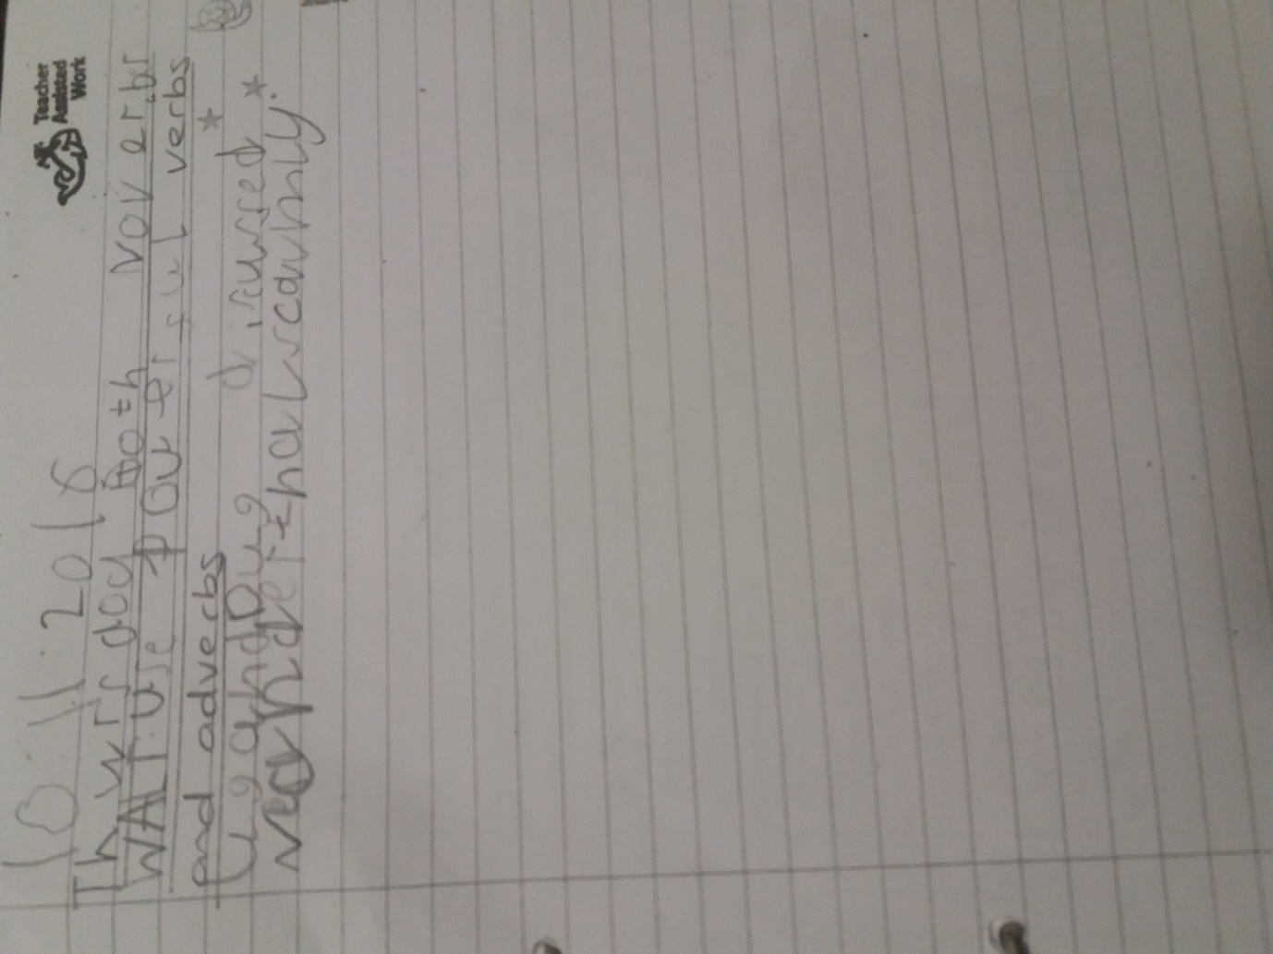
Following a mentoring meeting with my university partner I decided to help him by prompting him to look at his ideas one at a time and work through each one slowly working word by word to make it neater and helping it to make sense, he began to enjoy what he was writing, became proud of himself and more confident doing so. This helped to control and manage his behaviour in terms of being less distracting in class and better behaved.

Once he found he did better work in English when he took his time, asked for help, and worked through it methodically he began to try it in other classes too (eg maths and science).

