fSummary Table:

Code | G3.9.1
Title of Activity | A letter from the future
Type of Activity | Classroom discussion
Location of Activity | Classroom preferred
Duration | 50 minutes for group and class discussion
Optimum student number | Recommended number of students: 35 in groups of 3-5
Pre-requests
Purpose and short description | The purpose of this activity is to raise students' awareness about sustainable land use.  A letter from the future on the challenges we face to maintain our planet and hand it over to the future generations as good and resourceful as God created it.  Read and discuss with your partner and be prepared to share with others. How can we prevent ourselves from getting to this situation
Learning Objectives | - students state their role and contribution to face challenges to maintain and sustain their environment.  - students recognize and appreciate the importance of their current efforts for future generations.  - students develop communication skills through engaging in group tasks and class discussions.
Skills | Reading skills, communication skills, critical thinking skills, stage performance
Necessary Materials | Sheets of paper and pensils
Additional information
Vocabulary | Challenges, world peace, future generations
Assessment Method | Students performance, responses and contributions in the discussions are to be assessed via rubrics / observation sheets with five- point Likert scale items designed for assessing:  - reading and writing skills  - communication skill  - critical thinking skills
Materials for Assessment | Reading and writing assignments, rubrics and observation sheets
Extension and/or Adaptation ideas | Grade 9/ Social studies ,1st semester/ Unit 4, 2nd semester/ Unit 1
Information sources (if any) | http://www.unesco.org/education/tlsf/docs/module_1.doc http://plantphys.info/organismal/lechtml/taxonomy.shtml  http://conservapedia.com/Evolution

Links to EG school curriculum: Recommendation
Class / Discipline |  | Grade 9/ Science
Semester/Unit |  | 1st semester/ Unit 3

Implementation procedures
- Divide students into pairs.
- Give each pair 2 sheets of paper and a pencil.
- Cut the letter below into four segments and make copies.
- Ask each pair to read the whole letter and think about each paragraph of it and then share what they think of with their partners.
- Make clear that they are entitled to take notes.
- Ask students to develop 3 lists: one of current unsustainable practices and the second of sustainable actions and behaviours and the third of the future generations' recommendations for us.
- Hold a discussion with them all about the two lists
- Let students give their opinions of the suggestions future generations provide for maintaining a sustainable use of land resources until they take charge of them.

A Letter from the Future
Thank you for listening to this message from future generations – those of us who will inhabit this lovely planet for many decades to come. Our voices are usually overlooked by your generations, so we are very appreciative of your willingness to listen to our perspective.
Even though we live in a century very different from yours, we too work, play, talk, eat, laugh, hope, cry, sing, learn, worship, think, and wonder.
You are alive at a pivotal moment in humanity’s development. You are making some of the most important choices in human history. Your era is marked by positive and negative potentials of such newness and magnitude that you can hardly understand them.
Through your public policies and daily lives, the people of your era have tremendous power to influence the future course of humanity’s story. We strongly care about your choices, of course, since we benefit or suffer from them quite directly. We live downstream from you in time; whatever you put into the stream flows on to our era.
This is why we are very pleased that you care so deeply about the well-being of future generations. That is what we want most from you: your caring for us, your concern for our well-being, your willingness to take our needs as seriously as you take your own needs.
We admire and thank you for taking our needs seriously. We treasure our past and our predecessors as well as our future. We respect and love you. We hope that you and the children currently in your schools will continue care about us and will treat us with respect.
It is also true that we occasionally feel frustrated and angry with you for taking enormous risks that could severely damage our prospects, and for sometimes treating us in thoughtless, selfish, uncaring ways. At a deeper level, though, we feel a strong kinship bond with you, because all of us participate in the same never-ending procession of generations that stretches over the centuries. And all of us share a love for our home – that vibrant planet called Earth with its richly diverse geography and life.
It is our hope and trust that early 21st Century society does everything possible to help people feel a deep bonding or connectedness with all of humankind, with the planet and its diverse forms of life, and with future generations.
This is why we are pleased that the United Nations has made 2005–2014 a Decade of Education for Sustainable Development, and why we are happy that so many teachers are studying the UNESCO programme, Teaching and Learning for a Sustainable Future.
Source: This letter is a small, adapted section from Allen Tough’s on-line book A Message From Future Generations which provides a full copy of the letter.

Possible extension and/or adaptation

Read the following text and discuss in groups of three the challenges we should face to sustain our environment.

FIVE PRESSING ISSUES
Unfortunately, it is not only nature at risk! When we think of environmental problems, we often think first of the pollution of the natural environment – of the air, rivers, oceans and seas – and issues of climate change, forest clearing, waste disposal and so on.
However, there are also many problems with our social and economic systems that are causing difficulties for people all over the world. As a result, we are facing many pressing issues.
UNESCO has studied a wide range of these pressing issues and identified the following as the most serious:
- The rapid growth of the world’s population and its changing distribution
- The persistence of widespread poverty
- The growing pressures placed on the natural environment
- The continuing denial of democracy and human rights and the rise of conflict and violence
- The very notion of ‘development’ itself.

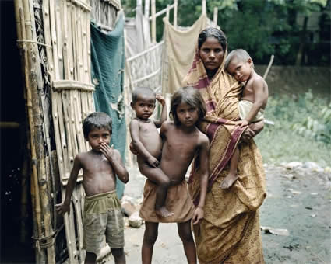
It is important to note that there are close interrelationships between all these five pressing issues. Indeed, it is not possible for any of them to be:
… examined or acted upon in isolation from the others. They are in constant interaction. Violence, for example, is, at once, a cause of poverty and its consequence. Growing populations place increasing stress on ecosystems, but human activity by contributing to climate change further intensifies population pressures though desertification and rising ocean levels. The issues, moreover, are not only related to one another in a physical manner, but also in a psychological sense. How people think about the issues – their knowledge, beliefs, attitudes and especially their values – is as important in the search for solutions as the ‘objective realities’ confronted.
z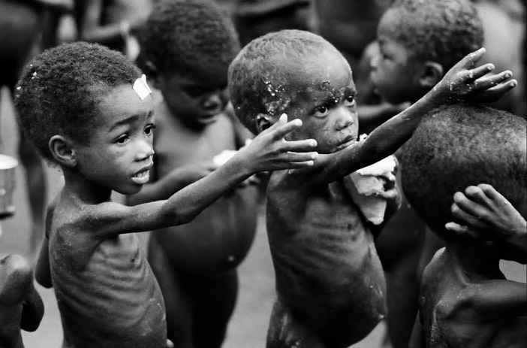

Summary Table:

Code | G3.9.2
Title of Activity | World population
Type of Activity | Class discussion
Location of Activity | Classroom
Duration | 50 minutes
Optimum student number | Recommended number of students: 35
Pre-requests
Purpose and short description | The purpose of this activity is to raise students' world population.  This activity provides data of world population and aims at raising students' awareness of how overpopulation threatens world resources
Learning Objectives | - students identify the size of world population, how fast it grows and.  - students identify some characteristics of world population.  - students recognize hazards of its growth and appreciate the importance of birth control.  - students develop communication skills through engaging in group tasks and class discussions.
Skills | Reading skills, communication skills, critical thinking skills, stage performance
Necessary Materials | - World Population Data Sheet  - Handout 1. Blank World Map  - copy of the "Double Up" student handout  - copy of the "Calculating Population Growth" student handout  - copy of the "Growth Rates Worldwide" student handouts  - calculator  - graph paper  - access to print and Internet resources
Additional information
Vocabulary | sustainable use of land, diversity, tolerance, world peace
Assessment Method | Students performance, responses and contributions in the discussions are to be assessed via rubrics / observation sheets with five- point Likert scale items designed for assessing:  - reading and writing skills  - communication skill  - critical thinking skills
Materials for Assessment | Reading and writing assignments, rubrics and observation sheets
Extension and/or Adaptation ideas | Grade 9, Science, 1st semester/ Unit 4
Information sources (if any) | Links and books  Web Sites  NOVA Web Site—World in the Balance  www.pbs.org/nova/worldbalance/  Earth Day Network  www.earthday.net/goals/issues.stm  Ecological Footprint Quiz  myfootprint.org  Population Growth Rate  www.worldbank.org/depweb/english/modules/social/pgr/  Population Issues Overview  www.unfpa.org/issues/index.htm  Population Reference Bureau  www.prb.org/  Six Billion and Beyond  www.pbs.org/sixbillion/  The World Bank Group: Data by Country  www.worldbank.org/data/countrydata/countrydata.html  World POPClock Projection  www.census.gov/cgi-bin/ipc/popclockw  World Population Prospects  esa.un.org/unpp/  Books  Bouvier, Leon F. and Jane T. Bertrand. World Population: Challenges for the 21st Century. Santa Ana, CA: Seven Locks Press, 1999.  Provides a history of population growth and covers issues ranging from immigration to family planning.  Fyson, Nance Lui. World Population. New York: F. Watts, 1998.  Examines the effects of agricultural, industrial, and medical factors on population growth.  Mazur, Laurie Ann. Beyond the Numbers: A Reader on Population, Consumption, and the Environment. Washington, DC: Island Press, 1994.  Presents essays reflecting eight population and consumption issues. Topics include gender equality, family planning, and reproductive rights.  Menzel, Peter. Material World: A Global Family Portrait. San Francisco: Sierra Club Books, 1994.  Presents the material possessions of average families throughout the world, featuring a photo of each family posing outside their home with all of their material goods surrounding them.  Newbold, K. Bruce. Six Billion Plus: Population Issues in the Twenty-First Century. Lanham, MD: Rowman & Littlefield Publishers, 2002.  Explores various impacts on population including HIV and AIDS,

Links to EG school curriculum: Recommendation
Class / Discipline | Grade 9/ Social studies
Semester/Unit | 1st semester/ Unit 2

Implementation Procedure:

- Since 1800, human population has grown from one billion to six billion people. Over the next half century, that number is projected to rise to nine billion. Tell students that in this activity they will investigate how long it takes the populations of different countries and territories to double.
- Before class, refer to the "Growth Rates Worldwide" student handouts to create a list of six to eight countries for each team. Try to make sure that each team's list includes countries with a range of growth rates and that the class data set represents countries on all of the continents (excluding Antarctica, which has no indigenous population). Choose countries with a growth rate of more than 0.044 to ensure that the rate will double in a reasonable time frame (Norway, with a rate of 0.044, takes 160 years to double; Japan, with a rate of 0.011, takes 630 years). See Activity Answer for some sample doubling rates. Don't choose countries with negative growth rates as they will never double.
- Organize the class into teams of four and provide copies of the student handouts and other materials to each team. Assign each team its set of countries.
- Define the meaning of growth rate: the increase in a country's population during a period of time expressed as a percentage of the population at the start of that time. For example, if a town had 75 people in 1980 and 100 people in 1981, the growth rate for the year would be 33 percent.
- Explain to students that they will be using 10-year compounded growth rates to determine when each country's population will double. The 10-year growth rate is based on annual growth rates from 2003 from the U.S. Bureau of Census International Database. The starting population for each country will be 50 individuals, and for this activity the growth rate will be assumed to be constant.
- Use the steps on the "Calculating Population Growth" student handout to demonstrate how to calculate future population sizes using the growth rate data.
- After teams have doubled the populations of all of their assigned countries, have teams graph their countries' population growths. Have students put the number of years on the x-axis in increments of 10 and the number of individuals on the y-axis in increments of five. Then ask students to draw the best-fit curve.
- If necessary, help students see that population growth is not a linear function; i.e., it produces a curved graph rather than a straight-line graph. Have teams answer the questions on their student handouts and hold a class discussion about their conclusions.
- Create a class histogram on the blackboard, posterboard, or an overhead to compare population doubling for each country. The histogram will need to have an upper time value of the country that takes the longest to double and should have an upper population size value of 150. Ask each team to represent each of its countries with a data point and an abbreviation of the country's name. Examine the histogram with students. Where do most of the countries in the class data set fall on the histogram? What else do students observe about the histogram? (Remind students that this does not represent all the world's countries.)
- Have students brainstorm a list of factors they think might affect growth rate (e.g., birthrate, death rate, access to medical care, nutrition, immigration, education, and income).
- Ask students to choose the four lowest and the four highest growth rate countries among their data sets or from the larger data table representing all the countries. Organize the class into teams belonging to two groups: Have one group use print and Internet resources to research some factors that contribute to low growth rates and the possible environmental, social, and economic impacts on the people within those populations; have the other group research factors contributing to high growth rates and the corresponding impacts on people in its populations. Have each team write a two-page report on its findings. Students can find some of this information in the CIA World Factbook, the World Bank Group Data Profile tables, and CountryReports.org at
www.cia.gov/cia/publications/factbook/
www.worldbank.org/data/countrydata/countrydata.html
www.countryreports.org/
- To conclude the lesson, discuss with students some of the factors affecting growth rates in the countries they researched. Do students see any commonalities among low-growth rate countries? Among high-growth rate countries? What are some of the differences between the factors among low-growth rate and high-growth rate countries?
- As an extension, have students choose countries with a negative growth rate and calculate the time it takes for a population to decrease to half its original size given an initial population size of 100 individuals. Then have them research reasons for negative growth rates.

Tools/Resources

The World Population Data Sheet at a Glance
Instructions
Find answers to the following questions using the current World Population Data Sheet. Provide students with blank world maps and have them locate, shade, and label the countries identified in the questions that follow.
- What is the current population of the world?
- Rank, in descending order, the 10 countries with the largest population.
Rates are often used, instead of absolute numbers, to determine how frequently a population or demographic event is occurring—rates show how common an event is. Rates also make it possible to compare countries that vary greatly in terms of population size.
The crude birth rate (CBR) is the annual number of births per 1,000 population.
- Which country has the highest CBR? Which country has the lowest?
The crude death rate (CDR) is the annual number of deaths per 1,000 population.
- Which country has the highest CDR? Which country has the lowest?
The infant mortality rate measures the number of deaths each year to infants under 1 year of age per 1,000 live births.
- Which country has the highest infant mortality rate and what is that rate? Which country has the lowest and what is that rate
The total fertility rate (TFR) is the average number of children a woman would have if she maintained today's level of childbearing throughout her reproductive years.
- Which countries share the highest TFR and what is it? Which countries share the lowest TFR. What is it?
The age and sex structure of a population refers to the number or proportion of males and females who are in each age category. Age-sex structure tells us about a population's past trends in fertility, mortality, and migration. It also provides information about the population's potential for future growth. The greater the proportion of people in the younger-adult age groups, the greater the potential for more births and population growth.
- Which country has the "youngest" population, that is, the highest proportion of population under age 15? Which country has the "oldest" population, that is, the highest proportion of population over age 64?
- In which country are people expected to live the longest? Which country has the lowest life expectancy?
- Which African country has the highest proportion of people living in urban areas? In Asia? In Latin America? In Europe? In Oceania?
Gross national income in purchasing power parity per capita (GNI PPP/capita) converts income into "international dollars" and indicates the amount of goods and services one could buy in the United States with a given amount of money.
- Which country is the wealthiest in terms of GNI PPP/capita? Which is the second wealthiest? Which are the poorest two countries?
A population grows because there are more births than deaths or more people are moving in than moving out. The difference between births and deaths is expressed as a percentage called the rate of natural increase.
- Which major region is growing the fastest through natural increase? Which major region is growing at the slowest rate? Within the major regions identified, which subregions are growing fastest? … slowest?
- Which country is growing the fastest through natural increase? Which country is growing at the slowest rate?
A population projection is a computation of future changes in population numbers based on assumptions about future trends in fertility, mortality, and migration.
- Rank the 10 countries with the largest projected populations for both 2025 and 2050 (in descending order).
- Which country (ies) is projected to drop out of the top 10 by 2050? Which country (ies) is projected to be added to the top 10?
- Rank the major regions according to population size (in descending order) for the present, for 2025, and for 2050. What trend can be observed in terms of population change?

Summary Table:

Code | G3.9.3
Title of Activity | Air pollution
Type of Activity | Case study and role-playing followed by classroom discussion.
Location of Activity | Classroom
Duration | 50 minutes
Optimum student number | 6 to 36 participants
Pre-requests | Students should have some background information of the impact of pollution on living organisms.
Purpose and short description | Students will explore the concept of pollution in general and Air pollution in particular and the sustainable efforts that should be exerted to keep air pollution rates within non-threatening levels for human health.  Students become town planners who are presented with a ‘fictional’ current situation in their town and must decide on sustainable actions in relation to air pollution, energy consumption, plantation, animal and human health, ...etc
Learning Objectives | - students explore how sustainable behaviour impacts not only the availability of resources but also the well-being of organisms.  - students develop an understanding of sustainable development.  - students improve communication skills through engaging in group tasks and class discussions.
Skills | Team work skills, writing skills, communication skills, creativity skills
Necessary Materials | A poster of a big crowded town, another of factories with chimneys, sheets of paper, pencils.
Additional information
Vocabulary | Resources, pollution, contamination, sustainable behaviour, communities
Assessment Method | Students performance, responses and contributions in the discussions are to be assessed via rubrics / observation sheets with five- point Likert scale items designed for assessing:  - reading and writing skills  - communication skill  - critical thinking skills
Materials for Assessment | Reading and writing assignments, rubrics and observation sheets
Extension and/or Adaptation ideas | Grade 9, Social studies, 1st semester/ Unit 2 & 3
Information sources (if any) | http://environment.nationalgeographic.com/environment/global-warming/pollution-overview/  http://www.nrdc.org/air/  http://www.thebigger.com/biology/pollution/what-is-air-pollution/  http://www.nlm.nih.gov/medlineplus/airpollution.html  ,

Links to EG school curriculum: Recommendation
Class / Discipline |  | Grade 9/ Science
Semester/Unit |  | 1st semester/ Unit 4

Implimentation Procedure:

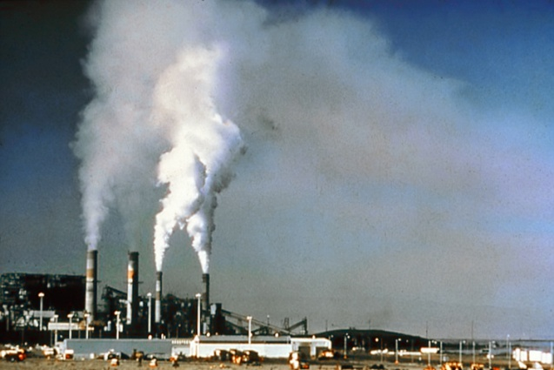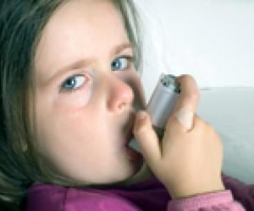
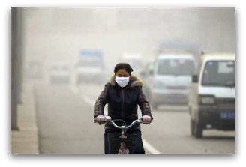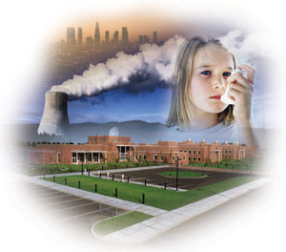

- Ask students to collect data and take pictures of violations committed in their own environment that enhance air pollution levels two days before the activity day.
- Divide the group into communities of six.
- Show students the above pictures indicating the impact of air pollution on living organisms in their environment and give each community 2 sheets of paper and a pencil .
- Tell them briefly and clearly that the air pollution levels in their town are going up and have become quite threatening for plantation and animal and human health.
- Ask them to work as officials in their town in charge of different sectors: police, agriculture, industry, electricity, water management, tranportation,...etc.
- Let each community hold a discussion on the procedures they will adopt and decisions they will make to confront this emergency.
- Have a whole clssroom discussion about the best rocedures and decisions reached.

Possible modifications and extensions:

- Read the following text and discuss in groups of three the damaging effects of air pollution on earth and go together over workable suggestions of minimizing these effects.

Air Pollution

Comes From Many Sources

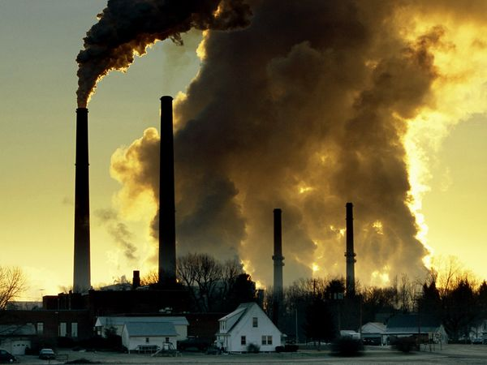Smog hanging over cities is the most familiar and obvious form of air pollution. But there are different kinds of pollution—some visible, some invisible—that contribute to global warming. Generally any substance that people introduce into the atmosphere that has damaging effects on living things and the environment is considered air pollution.
Carbon dioxide, a greenhouse gas, is the main pollutant that is warming Earth. Though living things emit carbon dioxide when they breathe, carbon dioxide is widely considered to be a pollutant when associated with cars, planes, power plants, and other human activities that involve the burning of fossil fuels such as gasoline and natural gas. In the past 150 years, such activities have pumped enough carbon dioxide into the atmosphere to raise its levels higher than they have been for hundreds of thousands of years.
Other greenhouse gases include methane—which comes from such sources as swamps and gas emitted by livestock—and chlorofluorocarbons (CFCs), which were used in refrigerants and aerosol propellants until they were banned because of their deteriorating effect on Earth's ozone layer.
Another pollutant associated with climate change is sulfur dioxide, a component of smog. Sulfur dioxide and closely related chemicals are known primarily as a cause of acid rain. But they also reflect light when released in the atmosphere, which keeps sunlight out and causes Earth to cool. Volcanic eruptions can spew massive amounts of sulfur dioxide into the atmosphere, sometimes causing cooling that lasts for years. In fact, volcanoes used to be the main source of atmospheric sulfur dioxide; today people are.
Industrialized countries have worked to reduce levels of sulfur dioxide, smog, and smoke in order to improve people's health. But a result, not predicted until recently, is that the lower sulfur dioxide levels may actually make global warming worse. Just as sulfur dioxide from volcanoes can cool the planet by blocking sunlight, cutting the amount of the compound in the atmosphere lets more sunlight through, warming the Earth. This effect is exaggerated when elevated levels of other greenhouse gases in the atmosphere trap the additional heat.
Most people agree that to curb global warming, a variety of measures need to be taken. On a personal level, driving and flying less, recycling, and conservation reduces a person’s "carbon footprint"—the amount of carbon dioxide a person is responsible for putting into the atmosphere.
On a larger scale, governments are taking measures to limit emissions of carbon dioxide and other greenhouse gases. One way is through the Kyoto Protocol, an agreement between countries that they will cut back on carbon dioxide emissions. Another method is to put taxes on carbon emissions or higher taxes on gasoline, so that people and companies will have greater incentives to conserve energy and pollute less.

Summary Table:

Code | G3.9.4
Title of Activity | The Great Energy Debate
Type of Activity | Classroom discussion
Location of Activity | Classroom
Duration | 50 minutes
Optimum student number | Two debating teams each consisting of 5 members, 5 students acting as jury members and 20 students as interactive audience totalling 35 students.
Pre-requests | Ideally students should have some understanding of sustainable and non-sustainable land use/building.
Purpose and short description | The activity aims at raising students' awareness of sources of energy and helping them compare the advantages and disadvantages of each through a classroom debate that triggers their competative skills and enthusiasm.
Learning Objectives | - identify sources of energy used in the world;  - distinguish between fossil fuels and renewable energy;  - describe how energy production and consumption can impact agriculture, people, the environment, economy; learn about alternatives to fossil fuels;
Skills | Team work skills, writing skills, communication skills, creativity skills
Necessary Materials | • Relevant articles from newspapers and magazines.  • A large number of small pebbles.  • Paper and pencils for keeping score.  Extension: A chalkboard and chalk.
Additional information
Vocabulary | Resources, pebbles, communities
Assessment Method | Students performance, responses and contributions in the discussions are to be assessed via rubrics / observation sheets with five- point Likert scale items designed for assessing:  - reading and writing skills  - communication skill  - critical thinking skills
Materials for Assessment | Reading and writing assignments, rubrics and observation sheets
Extension and/or Adaptation ideas | Grade 9, Social studies, 2nd semester/ Unit 1
Information sources (if any) | http://www.renewableenergyworld.com/rea/tech/home  http://www.gvepinternational.org/en/business/energy-enterprises?gclid=CNDjo_m5y64CFQWDDgod-D7H-w  http://www.nrea.gov.eg/english1.html  http://www.scienceonline.co.uk/energy/renewable-energy.html  http://www.eia.gov/kids/energy.cfm?page=renewable_home-basics

Links to EG school curriculum: Recommendation
Class / Discipline |  | Grade 9/ Science
Semester/Unit |  | 2nd semester/ Unit 2, lesson 3

Implimentation Procedure:
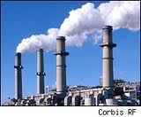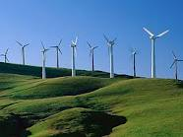

- Ask all students in the classroom to collect data for the debate topic which is energy sources.
- Have students list the ways they depend upon energy in their everyday lives. Then ask them to identify those activities that are dependent upon fossil fuels (e.g., oil, coal, and natural gas). List answers on the board.
- Next, ask them to think about and then discuss as a group the following questions:
- Where do these energy resources come from?
- How are our public lands connected to these resources?
- What is meant by the term "alternative energy"?
- What are some examples of alternative energy sources?
- Ask for volunteers to make two teams: each consisting of 5 members. The two teams are: an affirmative team supporting the renewable sources of energy and a negative one supporting fossil fuel.
- Select 5 more students to form the jury members who are to judge the performance of debaters.
- Ask the rest of students to make comment on debaters' constructive and rebuttle speeches, give their opinions of various issues, their own views of the arguments...etc,
- Ask debaters to support their speeches with evidence from articles, diagrams, tables and pictures from newspaper, magazines, websites, published data and statistics..
- Let the jury members together with the audience decide the winning or more persuasive team.

Possible extension and/or adaptation
Read the following text and discuss in groups of three the types of renewable sources of energy and how friendly they can be for our environment compared to fossil fuels.
Types of Renewable Energy
The United States currently relies heavily on coal, oil, and natural gas for its energy. Fossil fuels are non-renewable, that is, they draw on finite resources that will eventually dwindle, becoming too expensive or too environmentally damaging to retrieve. In contrast, the many types of renewable energy resources-such as wind and solar energy-are constantly replenished and will never run out.
Most renewable energy comes either directly or indirectly from the sun. Sunlight, or solar energy, can be used directly for heating and lighting homes and other buildings, for generating electricity, and for hot water heating, solar cooling, and a variety of commercial and industrial uses.

Solar shingles are installed on a rooftop. Credit: Stellar Sun Shop
The sun's heat also drives the winds, whose energy, is captured with wind turbines. Then, the winds and the sun's heat cause water to evaporate. When this water vapor turns into rain or snow and flows downhill into rivers or streams, its energy can be captured using hydroelectric power.
Along with the rain and snow, sunlight causes plants to grow. The organic matter that makes up those plants is known as biomass. Biomass can be used to produce electricity, transportation fuels, or chemicals. The use of biomass for any of these purposes is called bioenergy.

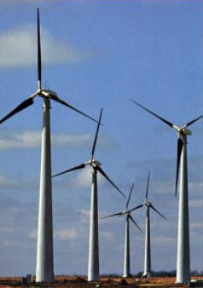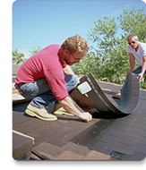Hydrogen also can be found in many organic compounds, as well as water. It's the most abundant element on the Earth. But it doesn't occur naturally as a gas. It's always combined with other elements, such as with oxygen to make water. Once separated from another element, hydrogen can be burned as a fuel or converted into electricity.
Not all renewable energy resources come from the sun. Geothermal energy taps the Earth's internal heat for a variety of uses, including electric power production, and the heating and cooling of buildings. And the energy of the ocean's tides come from the gravitational pull of the moon and the sun upon the Earth.
In fact, ocean energy comes from a number of sources. In addition to tidal energy, there's the energy of the ocean's waves, which are driven by both the tides and the winds. The sun also warms the surface of the ocean more than the ocean depths, creating a temperature difference that can be used as an energy source. All these forms of ocean energy can be used to produce electricity.

Code | G3.9.5
Title of activity | Safety first
Type of activity | Audit and class discussion
Duration | 1 hour maximum
Location | School and classroom
Optimum student number | 6 per group
Pre-requests
Purpose and short description | Students conduct a safety audit on their school to see how safe the school is and students will discuss how they could make their school safer
Learning objectives | - Students conduct a safety audit around the school grounds  - Students discuss issues relating to safety in the school and consider how they could make the school a safer place, if need be
Skills | Critical thinking skills, analysis skills, evaluation skills, discussion and communication skills
Necessary materials | Pen and paper
Additional information
Vocabulary | Audit, safety, safety equipment
Assessment method | - The teacher assesses the students ability to conduct the audit in the school and their ability to identify areas of safety concern in the school  - The class (and teacher) evaluates student’s suggestions for making the school a safer place. The class must decide which of the suggestions they should implement
Materials for assessment | n/a
Extension and/or adaptation ideas
Information sources (if any)

Links to EG school curriculum: Recommendation
Class / Discipline | Grade 9  Science
Semester/Unit | Unit 2 lesson 3 “technology and people”

Implementation procedures (Methodology)

- The teacher informs the students that they will be conducting a safety audit of the school in order to determine whether the school and its grounds are adequately safe for students and staff.

- The teacher asks students the following questions:
  - Are you aware of whether the school have a safety statement?
  - If it does, are you aware of what the safety statement says?
  - Are you aware what you should do in an emergency, for example a fire?
  - Have you ever taken part in an emergency drills (fire drill for example) in the school?
  - Do you generally feel safe in the school? Why/Why not?

- Now ask the students to identify key areas (perhaps 4/5 areas) in the school where safety is important/could be an issue: i.e. the playground, workshop, home economics room, gym, corridors etc.

- Ask each group of students to visit one area each and to answer the following questions on what they see in that area (note not all of these questions will be relevant to every area. Students could be invited to adapt these questions if need be):

Are safety images clearly portrayed? Yes No

Is safety equipment provided? Yes No

Are safety instructions provided when needed? Yes No

Are fire exits clearly marked? Yes No

Do all machines have a safety latch to ensure they cannot be used by someone who is unaware of the machine? Yes No

Are all solutions/chemicals stored in a secure locked location? Yes No

Are restricted areas clearly marked? Yes No

Is the playground area clearly identified? Yes No

Is the playground area fenced off? Yes No

- Groups are given 10 minutes to go to the assigned area and to return to the class with their completed answers

- The teacher calls on each group to share their answers with the class.

- The teacher divides the board into two: one section labelled Yes the other labelled no.

- Every time the response from the group is Yes the teacher writes the specific issue on the appropriate side of the board and the same for every time the response from the group is no

- Once all groups have provided their answer, the teacher invites the class to review the board and to determine whether the school is safe enough or whether there are areas in which safety could be improved.

- Students are invited to work in groups of 6 and to identify changes they could make to issues relating to safety in the school i.e. run a fire drill once every year

- All groups are invited to present their ideas to the class. These are all written on the board.

- Once all of the groups have presented their suggestions, the class must decide which one/two/three changes they should try to implement in order to make the school a safer place.

- The class could write a comprehension piece outlining the key changes they would propose and present it to the school principal.

Assessment

- The teacher assesses the students ability to conduct the audit in the school and their ability to identify areas of safety concern in the school
- The class (and teacher) evaluates student’s suggestions for making the school a safer place. The class must decide which of the suggestions they should implement

Possible modifications and extensions:

Tools/Resources

Summary Table:

Code | G3.9.6
Title of Activity | Sustainable life styles
Type of Activity | Debate
Location of Activity | Classroom or playground
Duration | 45 minutes
Optimum student number | 4 groups of 10/ 15 students each
Pre-requests
Purpose and short description | The students will learn the basics of having a constructive debate while presenting their point of view and being open to receive others’ points of view as well.understanding they can have different arguments and reach common grounds
Learning Objectives | - Learn how to conduct a debate objectively  - Analyze problems presented to them thoroughly presenting all the givens and possibilities  - Accepting the different opinions presented and responding positively to these differences
Skills | Composition – presentation – Reading – listening - stating hypothesis, looking at extrapolation of scenarios in a futuristic time frame.
Necessary Materials | Debate topics cards, papers, pens
Additional information
Vocabulary | Debate, scenarios, prediction, rainforest, sustainability, fauna, flora, endangered species, logic, consequences, ecotourism
Assessment Method | Presented result of the debate
Materials for Assessment
Extension and/or Adaptation ideas | Science Unit 2 lesson 3 “technology and people”
Information sources (if any)

Links to EG school curriculum: Recommendation
Class / Discipline | Grade 9: Arabic
Semester/Unit | Unit 3 “Science road”

Implementation procedures
Debate or debating is a formal method of interactive and representational argument. Debate is a broader form of argument than logical argument, which only examines what is or isn't the case or rhetoric which is a technique of persuasion. Though logical consistency, factual accuracy and some degree of emotional appeal to the audience are important elements of the art of persuasion, in debating, one side often prevails over the other side by presenting a superior "context" and/or framework of the issue, which is far more subtle and strategic.
In a formal debating contest, there are rules for people to discuss and decide on differences, within a framework defining how they will interact. Informal debate is a common occurrence, the quality and depth of a debate improves with knowledge and skill of its participants as debaters.
The major goal of the study of debate as a method or art is to develop one's ability to play from either position with equal ease.
http://en.wikipedia.org/wiki/Debate
In debating each team will present points in favor of their case. They will also spend some time criticizing the arguments presented by the other team. This is called rebuttal. There are a few things to remember about rebuttal.
1. Logic - to say that the other side is wrong is not enough. You have to show why the other side is wrong. This is best done by taking a main point of the other side's argument and showing that it does not make sense, because a lot of the thinking for this needs to be done quickly this is one of the most challenging and enjoyable aspects of debating.
2. Pick the important points - try to rebut the most important points of the other side's case. You will find that after a while these are easier and easier to spot. One obvious spot to find them is when the first speaker of the other team outlines briefly what the rest of the team will say. But do not rebut those points until after they have actually been presented by the other team.
3. `Play the ball' - do not criticize the individual speakers, criticize what they say. To call someone fat, ugly or a nerd does not make what they say wrong and it will also lose you marks.
Manner is how you present what you say and there are various aspects of manner that you need to be aware of. There is no one prescribed way of presenting your argument. It is not true, no matter what Paul Keating thinks, that the best way of being convincing is to shout and thump on the table. The best advice you can get is to develop a manner style that is natural to you. Here are some tips and pointers.
1. CUE CARDS. Do not write out your speech on cue cards. There is even a current, and indeed deplorable, trend towards computer generated cue cards. Debating is an exercise in lively interaction between two teams and between the teams and the audience, not in reading a speech. Use cue cards the same way you would use a prompt it a play, they are there for reference if you lose your spot. You can tell when someone is reading
2 EYE CONTACT. Is very closely related to cue cards. If you look at the audience you will hold their attention. If you spend your time reading from cue cards or looking at a point just above the audience's head they will lose concentration very quickly. When you've got them by the eyeballs their hearts and minds will follow.
3 VOICE. There are many things you can do with your voice to make it effective. You must project so that you can be heard but 4 minutes of constant shouting will become very annoying very quickly. Use volume, pitch and speed to emphasize important points in your speech. A sudden loud burst will grab your audience's attention while a period of quiet speaking can draw your audience in and make them listen carefully.
7 ELOCUTION AND OTHER BIG WORDS. This is not an exercise in grammar or elocution. Try to avoid being too informal but don't go overboard the other way. There are no marks to be gained from trying to use big words you don't understand or can't pronounce.
http://www.actdu.org.au/archives/actein_site/basicskills.html

Procedures:

The idea of sustainable development stems from the environmental and conservation movement of the 1970's and was largely centered on the environment. Currently, sustainability includes other questions of how resources are used, where they are taken from, who gets to use the resources, who gets to profit from the resources, and, finally, who decides all of the above. These are issues that now have legal, social, and ethical considerations. There are no easy solutions to these problems, but in the end, someone is going to be making decisions which affect everyone on Earth. Being informed is a must.
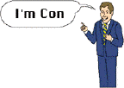- Here is a chance for you to see and explore many of these dilemmas. The following is a list of debate questions for you to use to build your knowledge of global sustainable development issues.
- Split your students into subgroups of 10/ 15 students
- give each subgroup and debate question card and ask them if they can come up with legal, social, and ethical issues and solutions.
Debate topics:
1. Should we capture wild animals and place them in a zoo for our enjoyment? For education? To keep species from dying out.
2. According to Environmental Science , there are about 1.28 billion cattle on Earth and each one eats about 900 pounds of vegetation. To make space for growing feed and raising cattle, developing nations are clearing millions of acres of tropical rainforests. Much of the land is cleared in order to meet consumer demands for meat, food crops, and timber. Because tropical rainforest soils are very fragile, ranches cannot maintain as many animals and thus are less efficient American and European ranches. Should rainforests be cleared for pasture for raising cows for exported hamburger? Should the United States and other developed countries tell developing countries how to use their resources?
3. at the Wadi Degla protectorate Park, there are many rare species of fauna, flora as well as fossils dating back to millions of years. Marble factories are being built in the area surrounding the protectorate as it is a suitable environment being considerably far from the city. The marble factories are very important to the economy of the country, however, these factories are the reason for a huge amount of air pollution due to the marble cutting. Should the EEAA allow the marble factories to be constructed in this area? If not, then what the solution would be
4. In Aswan the economy mainly relies on tourism. Big Nile cruises and hotels are a huge attraction to tourists all year long. While many houses of locals do not have access to potable water, these cruises and hotels get the permits to build big swimming pools for the tourists’ benefits using water resources in the area. What would be your fair solution?

Summary Table:

Code | G3.9.7
Title of Activity | What happens if we sleep for 100 years
Type of Activity | Essay
Location of Activity | Classroom
Duration | 45 minutes
Optimum student number | individuallly
Pre-requests
Purpose and short description | For the students to learn how to structure an essay and puttheir thoughts in writing by letting their creativity and imaginaiton go to its maximum capacity while trying to find ways to bring the earth to a better state.
Learning Objectives | - Learning how to write an essay  - Understanding the complexity of the humans’ activity on the earth and its impact  - Thinking of possible scenarios/ solutions that might improve the current state of the Earth
Skills | Writing- composition-spelling- presentation Reading, listening, stating hypothesis, looking at extrapolation of scenarios in a futuristic time frame.
Necessary Materials | Papers, pens, background on writing essays
Additional information
Vocabulary | Scenarios, nature, environment, species, endangered, impact, reducing, pollutants, fauna, flora, geology, topography, climate
Assessment Method | Rubric of assessment
Materials for Assessment | Rubric and pens
Extension and/or Adaptation ideas | Arabic  Unit 3 “Science road”
Information sources (if any)

Links to EG school curriculum: Recommendation
Class / Discipline | Grade 9, Science
Semester/Unit | Unit 2 lesson 3 “technology and people”

Background:
Essay Structure
Essay is just another word for story. Essays should have a beginning, a middle and an end.
Beginning
The beginning of a essay normally takes up around 1-2 paragraphs. These first paragraphs are where the topic is introduced and the main thrust of the essay is outlined. A good essay should begin with a definition of the main concept in the essay title. The introduction should then give a picture of what is going to be said within the essay.
Middle
The middle of an essay can be 3-5 paragraphs. Each paragraph needs a topic sentence. That's a sentence that tells what your paragraph is about. Most essays follow some kind of time line. What happened first, after that, next, finally and then a summary to wrap up what you just wrote about. Summaries can include a personal opinion about the topic. Details that support the topic is probably what a teacher means by being specific.
End
This last section of your essay should be the conclusion. It should not just be a summary of the whole essay, but it should contain some conclusions about what you have written.

Procedures:
- Present the below introduction to the students
When a weed appears from a crack in the concrete, I think we all secretly celebrate. For years now I’ve had eerie dreams of the streetscapes in 100 years, if all humans were frozen in time. I imagine the streets bulging with cracks, plants emerging, animals grazing, the air, earth, and sea filled with non-human nature again.
Imagine waking to the world 100 years from now - where nature had had a chance to be free and grow back. What would we see and feel on waking? Would we sense the possibilities of a life more in tune in nature or simply set about exploiting the earth’s natural resources again?
- Ask them to write an essay letting their imagination go wild thinking they would sleep for a 100 years to imagine what would life be when as they wake up to resume living.

Rubric for Essay

 | Great Performance | Good Performance | On its way | Needs Reinforcement
Relevance of content | The content of essay perfectly related to the topic given | The content of the essay is mostly related to the topic given | The content of the essay is barely related to the topic given | The content of the essay has no relevance to the topic given
 | Great Performance | Good Performance | On its way | Needs Reinforcement
Language utilization | The students are making exceptional use of the language and is relevant to the topic | The students put a good effort in making the best use of language and relevance to the topic in most of the essay | The students are barely using language properly and in relevance to the topic of the essay | The students are unable to make proper use of the language and is irrelevant to the topic of the essay
 | Great Performance | Good Performance | On its way | Needs Reinforcement
Structure | The essay is well structured and outlined | The essay has a fair structure and outline | The essay is poorly structured and outlined | The essay completely lack structure and outline
Structure | The essay is sequential and coherent in structure | The essay is sequential but not very coherent in structure | The essay is sequence and coherency is fair | The essay is not sequential and incoherent in structure
 | Great Performance | Good Performance | On its way | Needs Reinforcement
Creativity | The students are extremely creative in the ideas put in the essay letting their imagination go free | The students are fairly creative in the ideas put in the essay | The students are barely creative in the ideas put in the essay | The students lack any creativity or imagination in the ideas put in the essay

Code | G3.9.8
Title of activity | President week
Type of activity | Class project
Duration | 1 week with 5 class periods during that week
Location | Classroom/school
Optimum student number | 40-50 students
Pre-requests
Purpose and short description | Students enact and run a democratic election to elect a class president. They must suggest candidates that will run in the election. Each candidate must run a campaign; identify what values/policies they will run for and have a campaign manager. The entire class will vote for which candidate they want to be president. The votes are counted and the pretend president of the class is announced.
Learning objectives | - Students will conduct a mini election where they will campaign and elect a class president through a democratic process  - Students will explain how democracy and democratic elections work  - Students will gain a greater appreciation of the impact democracy has on lives in a country
Skills | Communication skills, critical thinking skills, application skills, debating and discussion skills
Necessary materials | Voting cards, paper, pens, posters, markers
Additional information
Vocabulary | Democracy, parliament, president, election, voting, campaign
Assessment method | - The teacher will evaluate students ability to conduct, run and complete a mini presidential election  - Students will complete a self assessment sheet on how their understanding and views of democracy. Students will also answer questions regarding democracy and democratic elections  - The teacher will evaluate students contributions to the discussion on the impact democracy has on lives in a country
Materials for assessment | Self assessment sheet
Extension and/or adaptation ideas | Grade 9, Math, Unit 6: Data Collection
Information sources (if any) | http://www.stanford.edu/~ldiamond/iraq/WhaIsDemocracy012004.htm

Links to EG school curriculum: Recommendation
Class / Discipline | Grade 9 – Social studies
Semester/Unit | Unit 2 Lesson 3 population characteristics

Implementation procedures (Methodology)

Class 1 (Early in the week)
- The teacher introduces the students to the idea of democracy
- The teacher asks students what they know about democracy
- All of the key words and phrases students say are written on the black board.
- The teacher hands out copies of the reading passage to students.
- Students read the passage and answer the question on the piece. These answers are fed back to the class as a whole.
- The teacher informs students that they will be running a democratic election on which they will vote for a class president on Thursday. The teacher asks students to consider what the role of a class president should entail i.e. represent the views and needs of the class to teachers and staff members, represent the class at various functions, deal with any concerns/issues within the class
- The teacher informs students that democracy can apply to how an election is run and to how governments work. The teacher asks students what they need to do to have a democratic election/government i.e. every person over a certain age can vote,

Some possible issues that could be raised include:
A democracy is a system of government that features the following:

  - A president comes into power through receiving the most votes in the election.
  - The elections is fair and everyone gets to vote in a free manner without any fear or concern regarding how they vote
  - The election is competitive i.e. more than one person is running for office.
  - Everybody’s civil rights are protected i.e. their right to speak out, the right to protest etc
  - Everybody’s political rights are protected i.e. the right to vote, the right to run for election.
  - There needs to be a free press that it is independent from of the government and not influenced and controlled by them
  - The working of government needs to be in a transparent manner i.e. the government works in the open, documents are made available to the public etc.
  - Citizens have a say and a vote in decisions that effect their constitutional rights i.e. the government cannot make decisions that impact on the people without getting the approval of the people first.

- The teacher asks students to decide who in the class should run for president. They can decide themselves how many people should run but they need to discuss the pros and cons of having a small/large number of candidates (small number you have limited choice and less competition etc.)
- If someone wishes to run for presidency, they need to be approved by two other class mates.
- All of those who receive two nominations are deemed appropriate to run for presidency.
- Each nominee must get a team around them i.e. campaign managers, someone responsible for PR (Public Relations – a person who is responsible for sending and receiving information from the public)
- Students are informed that the election will take place during class on Thursday and that everyone in the class gets to vote for who they want to be president

Class 2
- Students work in groups (with their candidate) to design their campaign. This can be in the form of posters, slogans, flyers, songs, dance etc.
- After 30 minutes each group is invited to present their campaign advertising briefly to the class i.e. talk through the poster, slogan, sing the song etc.
- Posters etc are placed around the class (and school if possible)

Class 3
- The class are informed that a speech and debate/question and answer session will take place between the candidates in the following class
- The group must work with the candidate to prepare a speech which the candidate must give in the next lesson
- The speech should highlight what the candidate stands for, what values/principles they have and what they hope to achieve when in office.
- Members of the public (i.e. class who are not running for election) must devise questions to ask the candidates for the following class

Class 4
- Each candidate is given 5 minutes to present their speech to the class
- After this, the class can ask questions to each candidate i.e. what do you bring to the role of president that the other candidates don’t?
- The class are informed that they will vote in the next class. The teacher informs students how they should vote i.e. that they should place a tick next to the candidates name that they wish to elect. The teacher should inform students what is meant by spoiled votes i.e. when someone puts a mark on their voting card that is different from one tick next to a candidate’s name

Class 5 (Thursday)
- Each student in the class receives a voting card (piece of paper) on which all of the names of the candidates are listed.
- Each person in the class can vote (privately) for the candidate they wish to be president
- All of the votes are placed in a secure box
- Once everyone has voted, all votes are counted and the spoiled votes are removed.
- The president is elected.
- The teacher asks students to consider what they have learned from the process of running and electing a president. The teacher puts students into groups of 6 and asks them to consider what are the positives of democracy: people have a voice and a right to choose who will represent them, the majority of people usually get what they want (most votes wins etc), people elected represent the public, cannot be controlled by one individual.
- The teacher calls on groups to present their answers
- The teacher concludes president week by asking students to complete a self feedback sheet

Assessment
- The teacher will evaluate students ability to conduct, run and complete a mini presidential election
- Students will complete a self assessment sheet on how their understanding and views of democracy
- The teacher will evaluate students contributions to the discussion on the impact democracy has on life in a country
Possible modifications and extensions:

Tools/Resources

Democracy 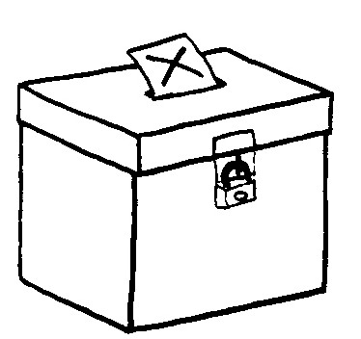

The word “democracy” combines two shorter words: “demos” meaning whole citizen living within a particular state and “kratos” meaning power or rule. However, both terms have more than one meaning (Arblaster, 1996). Some writers accept the definition of democracy as being ruled by the people or the many, including the poor. This was not necessarily the case in Ancient Greece, where the only participants were adult males who were eligible to serve in the defence forces. So a democratic state is one where a government is legally allowed to rule following an election process. Elections are therefore important in a democracy.
The popular understanding of the term “democracy” is that there are two basic forms: direct and representative. Direct democracy was that which was practised in ancient Athens. This form of government gave the right to participate in making political decisions to all who were called citizens (with the exception of women, slaves and those in the lower social classes) acting under procedures of majority rule. In a direct democracy there is a continuous participation of the citizens in the direct exercise of power. In large states (or countries such as Australia) this is not possible, except when the population votes in a referendum. Large populations restrict direct democracy because of the amount of time it would take to debate a range of complex issues. Virtually everywhere today, democracy is linked with some kind of representative system of government (Arblaster, 1996).
Representative democracy is characterised by the election of representatives, who are given responsibility by the people who elect them. This form of democracy limits the freedom of governments, as they are answerable to the people who vote. Therefore, if people do not like certain actions of the government they can vote them out (not vote for them) in the next election.
Democracies tend to prevent any individual from gaining control of government. Democratic forms of government provide the fairest method of governance to most people. Democracy provides for the protection of the rights of the individual, while the fact that politicians are answerable to the public through the election process means that the government pays some attention to what the public wants.
Often the term democracy means a particular type of society and not just the type of government or the means by which we choose a government. Democracy also refers to the ways in which the rights and responsibilities of individuals are understood and respected. A democratic society is one in which the majority of the population plays an active rather than a passive role. In a democracy there tends to be a feeling of fairness and equality among the people: the knowledge that every person has an equal right to be respected and listened to. The term democracy can be linked to certain civic rights, such as freedom from random arrest, freedom of religion, speech and so on.

Questions:
- What does the word democracy stand for?

- How is agreement reached in a democracy?

- Name and briefly explain the two forms of democracy.

- What are some of the benefits of a democratic government?

- What is meant by a democratic society?

Voting card

Please place a tick next to the candidate you wish to vote for

Candidate 1: ________________________

Candidate 2: ________________________

Candidate 3: ________________________

Candidate 4: ________________________

Candidate 5: ________________________

Self assessment sheet

Statement | Agree | Unsure | Disagree
I enjoyed the weeks activities

I have gained a greater understanding of how elections are run through engaging in these activities

I have gained a greater understanding of the meaning of democratic elections

I would like to engage in similar activities in the future

Code | G3.9.9
Title of activity | Viva la revolution!
Type of activity | Group task, interview and art work
Duration | 3*1 hour classes  1*.30 minute class
Location | Classroom
Optimum student number | Working individually or in groups of 6
Pre-requests
Purpose and short description | Students will work as a class to develop a book based on the experiences of people in their local community during the Egyptian Revolution. Students will either construct fictional stories (based on various newspaper stories) or they will interview local people in their community and write a story on them. The stories should explore the views and experiences of various people during the Revolution. The class will then design a cover (in the form of a small poster) for the book using the images below.
Learning objectives | - Students will explore and present the views and experiences of people in their community (and those portrayed in the newspapers) of the Egyptian revolution through developing a class book.  - students will gain a greater understanding of the Egyptian revolution
Skills | Communication skills, application skills, critical thinking skills, artistic skills, creativity skills, writing skills, researching skills.
Necessary materials | Newspaper cuttings, images, posters, glue/tape, pens, any other related resources, pen and paper
Additional information
Vocabulary | Revolution
Assessment method | - students will provide feedback on each others written piece and posters and will decide which poster should be used in the book  - The teacher will assess students answers to the questions around the revolution in the last session
Materials for assessment
Extension and/or adaptation ideas | Social studies, Unit 2 Lesson 3 population characteristics  Arabic language
Information sources (if any)

Links to EG school curriculum: Recommendation
Class / Discipline | Grade 9
Semester/Unit | Art, term 2: designing a book cover

Implementation procedures (Methodology)

Class 1 (1 hour):

- The teacher asks students to consider their memories and feelings regarding the Egyptian Revolution of 2011.
- Students are asked to write down two-three sentences regarding their feelings/experiences of the revolution. Students then share these in groups of 6. Please note: there is no right or wrong answer here. This is just about the students exploring their own views and feelings.
- Each group is asked to identify 2-3 things all members of the group had in common i.e. was their a similar emotion they all experienced etc?
- Students are informed that their class is going to form a book of the classes and the local community’s experiences and views of the Revolution. Please note: If this isn’t feasible students can read a number of newspaper articles and can write stories based on these articles.
- Students are placed back in to groups. Each group must decide whether they will write a ‘fictional’ story based on stories they read in the newspaper or whether they will interview people in their community/locality.
- If students decide to write fictional stories, they should be provided with a copy of the various newspaper and internet excerpts below. They should spend the remainder of the class reading these as a group. They should also be informed that they should try to discover other newspaper clippings before the next class.
- If students decide to conduct interviews with people in their community (family etc) they must spend the remainder of the class deciding who they should interview and also devising questions they can ask these people i.e. where were you when you heard about the start of the Revolution? What were your feelings during the time of the Revolution? Why do you think the Revolution occurred when it did? Who do you think was key in starting the Revolution? Looking back now, do you think that certain aspects of the Revolution could have been handled differently? If yes how? If no, why not? These are just a sample of questions and can be used as a guide. However this is not a definitive list.
- All groups are informed that they must come to the next class prepared to write a one page story (diary excerpt etc) based on a story they have developed from what they have read from newspaper cuttings or the interview they will conduct with a member of their community before the next class.

Class 2 (1 hour)

- Students are put back into their groups from the previous class.
- The group must work together to write a one page story based on either the interview they have conducted (using the answers to the interview questions as a guide) or based on a story they develop from the newspaper clippings. This story is entitled ‘my experiences of the Revolution’
- Students are given 35 minutes to write this story.
- Each group is called on to read their story to the class
- The class are invited to provide feedback on each groups story i.e. could the story be made more interesting? More true to life?
- each group must take a note of the feedback they receive
- The teacher will collect up each story and will correct it and indicate what changes should be made to each story.

Class 3 (1 hour)

- Students (working in groups of 6 again) must design a cover for the book based around their views and experiences of the Egyptian Revolution. Students must design a poster that is as creative as possible. They must draw on the stories they have written, excerpts from the newspaper cuttings below, images, their own drawings, excerpts from songs and poems and so on and include these on their poster as a possible cover for the book book.
- Students must consider in advance everything they add to their poster and ensure that they can explain what it means and why they placed it there.
- Students are given 45 hour to complete their scrapbook
- Each group must then present their book cover to the class, explaining all parts of it. Students must explain why they included certain images, cut outs, words on their book cover
- The class must decide which cover should be used for the book
- Each group will receive back their story with any corrections outlined by the teacher
- Each group must bring in a final altered version of their story prior to the next lesson. Please note: it is important that all groups write their stories on similar paper and paper of a similar size.

Class 4 (30 minutes)
Please note: Prior to this lesson the teacher will have collected up all of the revised stories which will be put into the final book. The teacher should attempt to bind these pages together either with thread or tape. The selected cover of the book should be placed in the front.

- The teacher shows the class the book and asks to look through it and asks for their views on the book
- The class can decide to display the book somewhere in the school or to present it as a gift to the school principal or someone else in their community.
- The teacher puts students back into groups. The group must discuss the following questions based on what they have learned from the activities
    - What were the positive consequences of the Revolution?
    - What were the negative consequences of the Revolution?
    - What lessons can we learn from all of our experiences of the Revolution?
26. The teacher calls on each group to call out their answers. All of these are written on the board

Assessment

Possible modifications and extensions:

Tools/Resources

Resources on which students can draw if they wish to write a fictional story of the revolution

a)

TIMELINE OF KEY DEVELOPMENTS
Tuesday, 1/25: First Day Of Demonstrations
Mubarak Faces Egypt Protests On 'Day Of Rage'
CAIRO (AP) -- Thousands of anti-government protesters, some hurling rocks and climbing atop an armored police truck, clashed with riot police Tuesday in the center of Cairo in a Tunisia-inspired demonstration to demand the end of Hosni Mubarak's nearly 30 years in power. (Scroll down for photos)
Police responded with blasts from water cannons and set upon crowds with batons and acrid clouds of tear gas to clear demonstrators crying out "Down with Mubarak" and demanding an end to Egypt's grinding poverty, corruption, unemployment and police abuses.
Tuesday's demonstration, the largest Egypt has seen for years, began peacefully, with police showing unusual restraint in what appeared to be a calculated strategy by the government to avoid further sullying the image of a security apparatus widely seen as little more than corrupt thugs in uniforms.
With discontent growing over economic woes, and the toppling of Tunisia's president still resonating in the region, Egypt's government - which normally responds with swift retribution to any dissent - needed to tread carefully.

Wednesday, 1/26: Protests Resume For Second Day

Defying an official ban on protests, Egyptian anti-government activists continued to rock Cairo with a series of violent demonstrations for the second day.
National police forces used tear gas, beatings and live ammunition in an effort to disperse the mass protests, staged in a Tunisian-inspired effort to oust President Hosni Mubarak from office.

Thursday, 1/27: Egypt Shuts Down The Internet

Reports are emerging that Internet has gone down in Cairo and throughout Egypt, only hours before the largest planned protests yet.

According to a report from The Arabist, "Egypt has shut off the internet."

The news of the Internet outage came minutes after the Associated Press published a video of an Egyptian protestor being shot.

CNN reporter Ben Wedeman confirmed Internet is down in Cairo and writes, "No internet, no SMS, what is next? Mobile phones and land lines? So much for stability.

Confirming what a few have reported this evening: in an action unprecedented in Internet history, the Egyptian government appears to have ordered service providers to shut down all international connections to the Internet. Critical European-Asian fiber-optic routes through Egypt appear to be unaffected for now. But every Egyptian provider, every business, bank, Internet cafe, website, school, embassy, and government office that relied on the big four Egyptian ISPs for their Internet connectivity is now cut off from the rest of the world.

Friday, 1/28: Mubarak Speaks, Says He'll Form A New Government

Egyptian President Hosni Mubarak acknowledged his citizens' discontent and attempted to defuse the crisis in Egypt Friday night by announcing that a new government is on the way. But the embattled president gave no indication that he himself planned to step down.
Specifically, Mubarak said that the current government has been asked to resign and he would appoint a new one on Saturday. He gave no indications he himself planned to step down, despite increasing calls for him to do so.
Mubarak's exact words: "I have requested the government to step down today. And I will designate a new government as of tomorrow to shoulder new duties."
The 82-year-old autocrat, who assumed power in Egypt 30 years ago, made the announcement following a day of widespread protests, violence and demonstrations. Just hours before the activity on the streets began, Egypt cut off Internet networks throughout the country.
Al Jazeera correspondent Sherine Tadros tweeted in response, "Mubarak says he'll fire govt but people are asking for regime change not a change in the regime!"

Sunday, 1/30: Hillary Clinton: Egypt Must Transition To Democracy

The U.S. appealed for an orderly transition to lasting democracy in Egypt even as escalating violence in the American ally threatened Mideast stability and put President Barack Obama in a diplomatic bind.

Secretary of State Hillary Rodham Clinton refused to speculate on the future of Egyptian President Hosni Mubarak or his teetering government. But U.S. officials, she said, "obviously want to see people who are truly committed to democracy, not to imposing any ideology on Egyptians."

She warned against a takeover resembling the one in Iran, with a "small group that doesn't represent the full diversity of Egyptian society" seizing control and imposing its ideological beliefs.

Clinton's comments came as the Obama administration tried to get a handle on the fast-moving situation in Egypt, a critical U.S. friend in the long quest for peace in the Middle East. Left largely unsaid is the growing fear that a government hostile to the U.S. could gain control of such a large and important Arab nation.

The U.S. wants to see "real democracy" emerge in Egypt, Clinton said, "not a democracy for six months or a year and then evolving into essentially a military dictatorship or a so-called democracy that then leads to what we saw in Iran."

Clinton, in interviews on the five Sunday morning TV shows, repeatedly stressed that Egypt's future lies in the hands of its people, hewing to the administration line of refusing to take sides publically in the upheaval.

While there have been repeated calls for Egypt to move toward democracy, it was not clear what efforts the administration may be making behind the scenes to influence the situation.

Obama called foreign leaders this weekend to convey his administration's desire for restraint and an orderly transition to a more responsive government in Egypt. The White House said he spoke with leaders from Britain, Turkey, Israel and Saudi Arabia, and sought their input. The president also got a briefing Sunday morning from his national security staff, and senior policy officials gathered for a deputies committee meeting to discuss the situation in Egypt.

Clinton made clear there are no discussions at this time about cutting off aid to Egypt, which receives about $1.5 billion in annual foreign assistance from the U.S. to help modernize its armed forces and strengthen regional security and stability. White House spokesman Robert Gibbs had said Friday that military and civilian aid was under review.

Asked if aid should be withheld, Senate Republican leader Mitch McConnell said the U.S. should wait and see what happens before making such decisions.

While Clinton did not voice support for a continued Mubarak reign or any other political party, she outlined U.S. expectations from any future government.

"There has to be a commitment by whoever is in the government that they will engage in a national dialogue with the people of Egypt, with the aim at taking actions that will meet the legitimate grievances of the Egyptian people for more participation, for respect for human rights, for the universal human rights they are entitled to, for economic reforms that will give more opportunity," she told reporters traveling with her to Haiti on Sunday.

Asked if she thought Mubarak had taken the necessary steps so far to hold on, Clinton said: "It's not a question of who retains power. . It's how are we going to respond to the legitimate needs and grievances expressed by the Egyptian people and chart a new path. Clearly, the path that has been followed has not been one that has created that democratic future, that economic opportunity that people in the peaceful protests are seeking."

Sen. John McCain, R-Ariz., demurred when asked if the U.S. should abandon support of Mubarak. He said the U.S. needs to "be on the right side of history" and do a better job of arguing for human rights.

"It was clear for a long time that the kind of repressive regime . that Mubarak controls, sooner or later there is going to be great difficulties," said McCain.

House Speaker John Boehner praised the administration's handling of the situation and said the U.S. must continue to support Egypt's move to democracy.

"What we don't want are radical ideologies to take control of a very large and important country in the Middle East," he said.

The State Department is recommending that Americans leave Egypt as soon as possible and said it is prepared to evacuate thousands of U.S. citizens on chartered planes beginning Monday. Due to Internet interruptions, however, officials said they must rely largely on friends and families in the U.S. to relay that information to the stranded Americans.

Assistant Secretary of State Janice Jacobs told reporters Sunday that it will take several flights over the coming days to accommodate all American citizens who want to leave the country.

Officials are considering three possible destinations, Athens, Greece; Istanbul, Turkey; and Nicosia, Cyprus. Jacobs, who's in charge of consular affairs, said the U.S. may also send planes to other cities in Egypt, such as Luxor, if there are a number of Americans stranded there. Americans taking the charter will be billed for the flight and must make their own travel arrangements home from Europe.

Anyone needing information on the flights should check the State Department and U.S. embassy websites or send an e-mail to egyptemergencyusc(at)state.gov. They can also call 1-888-407-4747 toll-free from within the U.S. and Canada. From outside the U.S. and Canada people can call 1-202-501-4444.

Canada announced Sunday it would charter flights as early as Monday that will fly Canadians who wish to leave to London, Paris or Frankfurt.

U.S. military leaders reached out to their counterparts in Egypt and the Middle East. Defense Secretary Robert Gates spoke to Egypt and Israel's ministers of defense. Adm. Mike Mullen, chairman of the Joint Chiefs of Staff, called Egyptian Lt. Gen. Sami Enan, expressing his appreciation for the continued professionalism of Egypt's military during the crisis, said Mullen spokesman Capt. John Kirby.

Mubarak appointed a vice president on Saturday for the first time in more than 30 years – the U.S. long has pressed for that and Clinton called it the "bare beginning of what needs to happen" – and has pledged to make reforms.

"We want to see free and fair elections and we expect that this will be one of the outcomes of what is going on," Clinton said, adding that the U.S. is committed to working with the Egyptians who are interested in true democracy.

Monday, 1/31: Egypt's New Government Is Announced, Sworn In

Egyptian President Hosni Mubarak swore in a new Cabinet on Monday, replacing one dissolved as a concession to unprecedented anti-government protests.
In the most significant change, the interior minister - who heads internal security forces - was replaced. A retired police general, Mahmoud Wagdi, was named to replace Habib el-Adly, who is widely despised by protesters for brutality shown by security forces.
Still, the new Cabinet is unlikely to satisfy the tens of thousands of protesters who have taken to the streets in cities across Egypt the past week demanding nothing short of the ouster of Mubarak and his entire regime. As news of the appointments broke, thousands massed in the protest's epicenter, Cairo's central Tahrir Square, broke into chants of "we want the fall of the regime."
"We dont recognize any decisions Mubarak has taken since Jan. 25," Mostafa el-Naggar, a supporter of prominent reform advocate Mohamed ElBaradei, referring to the first day of the protests. "This is a failed attempt - he is done with."
Mubarak announced the dissolving of the previous government late Friday, naming his intelligence chief and close aide Omar Suleiman as vice president and former Air Force general Ahmed Shafiq as prime minister. But protesters immediately rejected the move as an attempt by Mubarak, Egypt's authoritarian ruler of nearly 30 years, to cling to power.
The new line-up of Cabinet ministers announced on state television included stalwarts of Mubarak's regime but purged several of the prominent businessmen who held economic posts and have engineered the country's economic liberalization policies the past decades. Many Egyptians resented to influence of millionaire politician-moguls, who were close allies of Mubarak's son, Gamal, long thought to be the heir apparent for the presidency.
In the new Cabinet, Mubarak retained his long-serving defense minister, Field Marshal Hussein Tantawi - and gave him an additional title of deputy prime minister - and also kept Foreign Minister Ahmed Aboul Gheit.
But for some posts, Mubarak brought in new blood by naming figures who hold widespread respect in their fields. For example, Gaber Asfour, a prominent literary figure, was named culture minister. He replaced the longest-serving Cabinet member, Farouq Hosni, who had held the post for more than 25 years. Also, Egypt's most famous archaeologist, Zahi Hawass, was named state minister for antiquities, a new post.
State newspapers on Monday published a sternly worded letter from Mubarak to his new prime minister, Shafiq, ordering him to move swiftly to introduce political, legislative and constitutional reforms.
He also appeared to distance himself from the economic policies directed by his son Gamal, widely blamed for causing a wide gap between the rich and poor, for whom economic hardships have deepened. In the letter, Mubarak urged "new economic policies that give maximum care to an economic performance which pays heed to the suffering of the citizens, and lightening their burden."

Tuesday, 2/1: President Mubarak Says He Won't Run For Re-Election

Egyptian President Hosni Mubarak said he will not run for a new term in office in September elections, but rejected demands that he step down immediately and leave the country, vowing to die on Egypt's soil, in a television address Tuesday after a dramatic day in which a quarter-million protesters called on him to go.
Mubarak said he would serve out the rest of his term working to ensure a "peaceful transfer of power" and carry out amendments to rules on presidential elections.
But the half-way concession - an end to his rule months down the road - was immediately derided by protesters massed in Cairo's main downtown square.
Watching his speech on a giant TV set up in Tahrir square, protesters booed and waved their shoes over the heads in a sign of contempt. "Go, go, go! We are not leaving until he leaves," they chanted, and one man screamed, "He doesn't want to say it, he doesn't want to say it."
The 82-year-old Mubarak, who has ruled the country for nearly three decades, insisted that his decision not to run had nothing to do with the unprecedented protests that have shaken Egypt the past week. "I tell you in all sincerity, regardless of the current circumstances, I never intended to be a candidate for another term."
"I will work for the final remaining months of the current term to accomplish the necessary steps for the peaceful transfer of power," he said.
Mubarak, a former air force commander, resolutely vowed not to flee the country. "This dear nation .. is where I lived, I fought for it and defended its soil, sovereignty and interests. On its soil I will die. History will judge me like it did others."
His speech came after a visiting envoy of President Barack Obama told Mubarak that his ally the United States sees his presidency at an end. Frank Wisner, a respected former U.S. ambassador to Egypt who is a friend of the Egyptian president, made clear to Mubarak that the U.S "view that his tenure as president is coming to close," according to an administration official, who spoke on condition of anonymity because of the delicacy of the ongoing diplomacy

Wednesday, 2/2: Internet Service Returns In Egypt

Internet access has resumed in the Egyptian cities of Cairo and Alexandria after five days of cut connections, Internet users reported on Wednesday.
Access to the Internet has been cut since January 28 in what appeared to be an attempt to stop the frenzied online spread of dissent during a wave of nationwide protests against President Hosni Mubarak's 30-year-rule.

Thursday, 2/3: Foreign Journalists Rounded Up

CAIRO - Egyptian army tanks and soldiers cleared away pro-government rioters and deployed between them and protesters seeking the fall of President Hosni Mubarak, as the prime minister made an unprecedented apology Thursday for the assault by regime backers that turned central Cairo into a battle zone.
Prime Minister Ahmed Shafiq told state TV that the attack Wednesday on the anti-government protesters was a "blatant mistake" and promised to investigate who was behind it.
But about the same time Shafiq was issuing an apology, another government official was denying a direct link to the violence by Mubarak supporters. As relayed by the BBC:
A cabinet spokesman Magdy Rady has insisted to Reuters that the government had no role in mobilising pro-Mubarak groups. "To accuse the government of mobilising this is a real fiction. That would defeat our object of restoring the calm."
Also in Egypt, foreign journalists were beaten with sticks and fists by pro-government mobs on the streets Cairo on Thursday and dozens were reported detained by security forces in what the U.S. called a concerted attempt to intimidate the press.
Two New York Times reporters were detained in Cairo and later released. The Washington Post's Cairo bureau chief and a photographer were reportedly arrested.
The protesters accuse the regime of organizing the assault, using paid thugs and policemen in civilian clothes, in an attempt to crush their movement. Government supporters charged central Tahrir Square Wednesday afternoon, sparking 15 hours of uncontrolled chaos, with the two sides battled with rocks, sticks, bottles and firebombs as soliders largely stood by without intervening.
The military began to move with muscle for the first time to stop the fighting early Thursday after a barrage of automatic gunfire hit the anti-government camp before dawn, killing at least three protesters in a serious escalation.
Four tanks cleared a highway overpass from which Mubarak supporters had hurled rocks and firebombs onto the protesters. Soldiers on the streets carrying rifles lined up between the two sides around 11 a.m. Several hundred other soldiers were moving toward the front line.
Thursday morning, more protesters streamed into the square, joining the thousands of defenders who spent the chilly night there, hunkered down against the thousands of government supporters in the surrounding streets.
A sense of victory ran through the protesters, even as they organized their ranks in the streets in case of a new assault. "Thank God, we managed to protect the whole area," said Abdul-Rahman, a taxi driver who spent the night in the square. "We prevented the pro-Mubarak people from storming the streets leading to the square." He refused to give his full name.
The apology by Shafiq, who was appointed by Mubarak over the weekend, was highly unusual from a leadership that rarely makes public admissions of a mistake. His promise to investigate who organized the attack came only hours after the Interior Ministry issued a denial that any of its police were involved.
"I offer my apology for everything that happened yesterday because it's neither logical nor rational," Shafiq said. "What happened was wrong, a million percent wrong, whether it was deliberate or not deliberate ... Everything that happened yesterday will be investigated so everyone knows who was behind it."

The anti-Mubarak movement, which has carried out an unprecedented 10 days of protests bringing as many as quarter-million people into Tahrir, has vowed to intensify protests to force him out by Friday. In a speech Tuesday night, Mubarak refused to step down immediately, saying he would serve out the remaining seven months of his term -- a halfway concession rejected by the protesters.

Friday, 2/4: "Day of Departure" Protests Held Across Egypt

Opposition parties called for Feb. 4 to be a "Day of Departure" earlier this week, AllVoices reports. The plan: to come together in massive numbers and in one voice demand President Hosni Mubarak to step down once and for all.
An Al Jazeera analyst said the goal was clear: "The idea is to send a message, and have the largest amount of people participate."
Protesters demanding Mubarak's ouster packed Cairo's central square in huge numbers Friday, waving Egyptian flags, singing the national anthem and cheering, appearing undaunted and determined after their camp withstood two days of street battles with regime supporters trying to dislodge them.
Thousands more flowed over bridges across the Nile into Tahrir Square, a sign that they were not intimidated after fending off everything thrown at the protesters by pro-Mubarak attackers -- stones, firebombs, fighters on horses and camels and automatic gunfire. The protesters passed through a series of beefed-up checkpoints by the military and the protesters themselves guarding the square.
The crowd, well over 10,000, was the biggest since Tuesday, when a quarter-million turned out. They chanted, prayed and unfurled a long banner in the national colors of red, black and white. A man sitting in a wheelchair was lifted -- wheelchair and all -- over the heads of the crowd and he pumped his arms in the air.
Egyptian Defense Minister Hussein Tantawi and senior army officials visited the square Friday morning and soldiers were checking IDs and performing body searches at its entrances, a sign that Egypt's most powerful institution was sanctioning the demonstration.
The New York Times reports that live video feeds were cut off in the square Thursday evening and numerous journalists have been attacked and detained, so it's not clear how well the media will be able to report Friday's happenings.
Coinciding with "Day of Departure" events in Egypt, a demonstration is planned for Feb. 4 in New York City's Times Square, beginning at 3:30 p.m. local time. Meanwhile, a "Day of Rage" is planned in Syria for Feb. 4, with major protests in the capital city of Damascus.
The Obama administration said it was in talks with top Egyptian officials about the possibility of Mubarak immediately resigning, and an interim government forming before free and fair elections this year.
U.S. officials said the creation of a military-backed caretaker government was one of several ideas being discussed between the Egyptian regime and the Obama administration. The American officials spoke on condition of anonymity to discuss the continuing sensitive talks.
Among the options was a proposal for Mubarak to resign immediately and cede power to a transitional government run by Vice President Omar Suleiman, the officials said.

Saturday, 2/5: Members Of Ruling Party Leadership Resign

CAIRO - State TV says the top leadership body of Egypt's ruling party, including the president's son Gamal Mubarak and the party secretary-general Safwat el-Sharif, resigned Saturday in a new gesture apparently aimed at convincing anti-government protesters that the regime is serious about reform.
Protesters have shrugged off other concessions by the regime in the past 12 days of unprecedented street demonstrations, saying they will settle for nothing less than the immediate ouster of President Hosni Mubarak, Egypt's ruler for nearly 30 years.
State TV said the ruling party's six-member Steering Committee of the General Secretariat stepped down and was replaced. The council was the party's highest decision-making body, and el-Sharif and other outgoing members were some of the most powerful -- and to many Egyptians, unpopular -- political figures in the regime.
El-Sharif was replaced by Hossam Badrawi, a party figure who had been sidelined within its ranks in recent years because of his sharp criticisms of some policies.
The new appointments to the body were largely young figures, one of the replacements Mohammed Kamal told The Associated Press. "It's a good change. It reflects the mood of change that is sweeping the country," he said.
Gamal Mubarak, who was a member of the Steering Committee, was widely seen as being groomed by his father Hosni Mubarak to succeed him as president. But Vice President Omar Suleiman promised earlier in the week that Gamal would not run for president in elections due in September.
The younger Mubarak was also head of the party's powerful policies committee, where for the past decade he led a campaign of economic liberalization. State TV said Gamal was also removed from that post and replaced by Badrawi.
The announcement was greeted with scorn by some of the tens of thousands of protesters gathered in Cairo's Tahrir Square. Wael Khalil, a 45-year-old activist, said it would "reinforce their (protesters') resolve and increase their confidence because it shows that they are winning, and the regime is retreating inch by inch."

Sunday, 2/6: Government Agrees On Concessions

CAIRO — Egypt's vice president met a broad representation of major opposition groups for the first time Sunday and offered new concessions including freedom of the press, release of those detained since anti-government protests began nearly two weeks ago and the eventual lifting of the country's hated emergency laws.
Two of the groups that attended the meeting said this was only a first step in a dialogue which has yet to meet their central demand -- the immediate ouster of longtime President Hosni Mubarak.
"People still want the president to step down," said Mostafa al-Naggar, a protest organizer and supporter of Mohamed ElBaradei, a Nobel Peace laureate and one of the country's leading democracy advocates.
"The protest continues because there are no guarantees and not all demands have been met," he added. "We did not sign on to the statement. This is a beginning of a dialogue. We approve the positive things in the statement but ... we are still demanding that the president step down."
The outlawed Muslim Brotherhood, the country's largest opposition group, made a similar statement after its representatives attended the meeting.
Vice President Omar Suleiman offered to set up a committee of judiciary and political figures to study proposed constitutional reforms that would allow more candidates to run for president and impose term limits on the presidency, the state news agency reported. The committee was given until the first week of March to finish the tasks.

Tuesday, 2/8: Freed Activist Energizes Protests

CAIRO -- A young leader of Egypt's anti-government protesters, newly released from detention, joined a massive crowd in Cairo's Tahrir Square for the first time Tuesday and was greeted with cheers, whistling and thunderous applause when he declared: "We will not abandon our demand and that is the departure of the regime."
Many in the crowd said they were inspired by Wael Ghonim, the 30-year-old Google Inc. marketing manager who was a key organizer of the online campaign that sparked the first protest on Jan. 25 to demand the ouster of President Hosni Mubarak. Straight from his release from 12 days of detention, Ghonim gave an emotionally charged television interview Monday night where he sobbed over those who have been killed in two weeks of clashes.
He arrived in the square when it was packed shoulder-to-shoulder, a crowd comparable in size to the biggest demonstration so far that drew a quarter-million people. He spoke softly and briefly to the huge crowd from a stage and began by offering his condolences to the families of those killed.
"I'm not a hero but those who were martyred are the heroes," he said, breaking into a chant of "Mubarak leave, leave." When he finished, the crowd erupted in cheering, whistling and deafening applause.
Ghonim has emerged as a rallying point for protesters, who reject a group of traditional Egyptian opposition groups that have met with the government amid the most sweeping concessions the regime has made in its three decades in power.

Wednesday, 2/9: Widespread Labor Strikes Throughout Egypt

CAIRO - Thousands of state workers and impoverished Egyptians launched strikes and protests around the country on Wednesday over their economic woes as anti-government activists sought to expand their campaign to oust President Hosni Mubarak despite warnings from the vice president that protests won't be tolerated much longer.
Some 8,000 protesters, mainly farmers, set barricades of flaming palm trees in the southern province of Assiut, blocking the main highway and railway to Cairo to complain of bread shortages. They then drove off the governor by pelting his van with stones. Hundreds of slum dwellers in the Suez Canal city of Port Said set fire to part of the governor's headquarters in anger over lack of housing.
Efforts by Vice President Omar Suleiman to open a dialogue with protesters over reforms have broken down since the weekend, with youth organizers of the movement deeply suspicious that he plans only superficial changes far short of real democracy. They refuse any talks unless Mubarak steps down first.
Showing growing impatience with the rejection, Suleiman issued a sharp warning that raised the prospect of a renewed crackdown. He told Egyptian newspaper editors late Tuesday that there could be a "coup" unless demonstrators agree to enter negotiations. Further deepening skepticism of his intentions, he suggested Egypt was not ready for democracy and said a government-formed panel of judges, dominated by Mubarak loyalists, would push ahead with recommending its own constitutional amendments to be put to a referendum.
"He is threatening to impose martial law, which means everybody in the square will be smashed," said Abdul-Rahman Samir, a spokesman for a coalition of the five main youth groups behind protests in Cairo's Tahrir Square. "But what would he do with the rest of the 70 million Egyptians who will follow us afterward."
Suleiman is creating "a disastrous scenario," Samir said. "We are striking and we will protest and we will not negotiate until Mubarak steps down. Whoever wants to threaten us, then let them do so," he added.

Nearly 10,000 massed in Tahrir on Wednesday in the 16th day of protests. Nearby, 2,000 more blocked off parliament, several blocks away, chanting slogans for it to be dissolved. Army troops deployed in the parliament grounds.
For the first time, protesters were calling forcefully Wednesday for labor strikes, despite a warning by Suleiman that calls for civil disobedience are "very dangerous for society and we can't put up with this at all."

Thursday, 2/10: Despite Rumors, Mubarak Refuses To Step Down

Egypt's Hosni Mubarak refused to step down or leave the country and instead said he would hand his powers to his vice president Thursday, remaining president and ensuring regime control over the reform process. Stunned protesters in central Cairo who demand his ouster waved their shoes in contempt and shouted, "Leave, leave, leave."
The rapidly moving events raised the question of whether a rift had opened between Mubarak and the military command. Hours earlier, a council of the military's top generals announced it had stepped in to secure the country, and a senior commander announced to protesters in Tahrir Square that all their demands would soon be met, raising cries of victory that Mubarak was on his way out.
After Mubarak's speech, protest organizers called for the army to take action to oust him, and they vowed increased protests on Friday. Several hundred thousand had packed into Tahrir Square, ecstatic with expectation that Mubarak would announce his resignation in his nighttime address. Instead, they watched in shocked silence as he spoke, slapping their foreheads in anger and disbelief. Some broke into tears.
Around a 1,000 marched on the state television headquarters several blocks away, guarded by the military with barbed wire and tanks. "They are the liars," the crowd shouted, pointing at the building, chanting, "We won't leave, they will leave."
Prominent reform advocate, Nobel Peace laureate Mohamed ElBaradei, whose supporters were among the organizers of the 17-day-old wave of protests, issued a Tweet calling on the military to act.
"The army must save the country now," he said. "I call on the Egyptian army to immediately interfere to rescue Egypt. The credibility of the army is on the line."
Mohammed Mustapha, a protest spokesman, said, "We are waiting for a strong reaction from the army to Mubarak's speech." He said "huge numbers" of protesters were expected Friday and that many wanted to march on the Oruba palace, Mubarak's main presidential palace several miles away from Tahrir.
Immediately after Mubarak's speech, Vice President Omar Suleiman called on the protesters to "go home" and asked Egyptians to "unite and look to the future."
In his 17-minute speech on state TV, Mubarak spoke as if he were still in charge, saying he was "adamant to continue to shoulder my responsibility to protect the constitution and safeguard the interests of the people." He vowed that he would remain in the country and said he was addressing the youth in Tahrir as "the president of the republic."
"I saw fit to delegate the authorities of the president to the vice president, as dictated in the constitution," said Mubarak, who looked frail but spoke in a determined, almost defiant voice.
Suleiman was already leading the regime's efforts to deal with the crisis. The constitution allows the president to transfer his powers if he is unable to carry out his duties "due to any temporary obstacle," but it does not mean his resignation. Even in that case, the vice president still cannot request constitutional amendments or dissolve parliament.

Friday, 2/11: Mubarak Resigns as president and leaves Cairo

Egypt's Hosni Mubarak resigned as president and handed control to the military on Friday, bowing down after a historic 18-day wave of pro-democracy demonstrations by hundreds of thousands. "The people ousted the president," chanted a crowd of tens of thousands outside his presidential palace in Cairo.
Several hundred thousand protesters massed in Cairo's central Tahrir Square exploded into joy, waving Egyptian flags, and car horns and celebratory shots in the air were heard around the city of 18 million in joy after Vice President Omar Suleiman made the announcement on national TV just after nightfall.
Mubarak had sought to cling to power, handing some of his authorities to Suleiman while keeping his title. But an explosion of protests Friday rejecting the move appeared to have pushed the military into forcing him out completely. Hundreds of thousands marched throughout the day in cities across the country as soliders stood by, besieging his palace in Cairo and Alexandria and the state TV building.
"In these grave circumstances that the country is passing through, President Hosni Mubarak has decided to leave his position as president of the republic," a grim-looking Suleiman said. "He has mandated the Armed Forces Supreme Council to run the state. God is our protector and succor."
Nobel Peace laureate Mohammed ElBaradei, whose young supporters were among the organizers of the protest movement, told The Associated Press, "This is the greatest day of my life."
"The country has been liberated after decades of repression," he said adding that he expects a "beautiful" transition of power.

b) images students can use to make front cover of the book

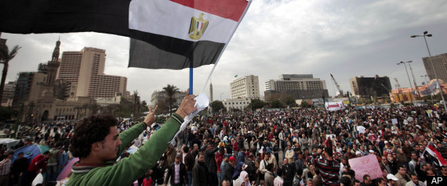

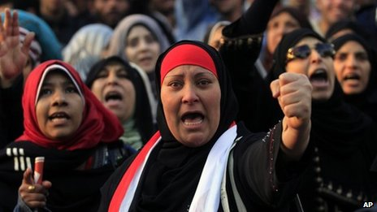

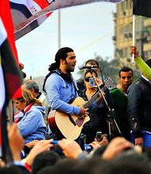

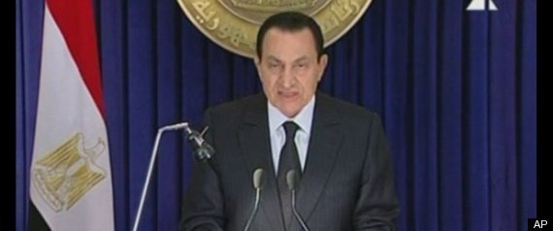

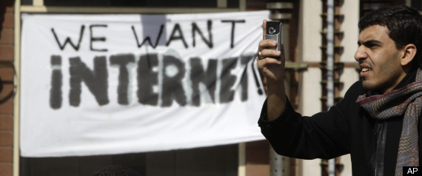

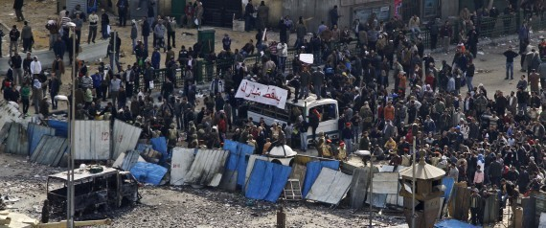

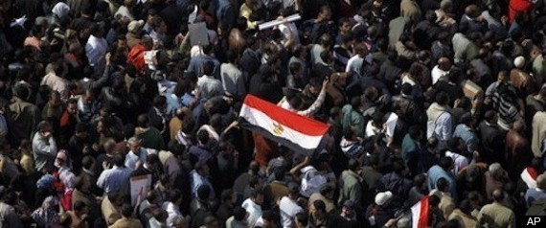

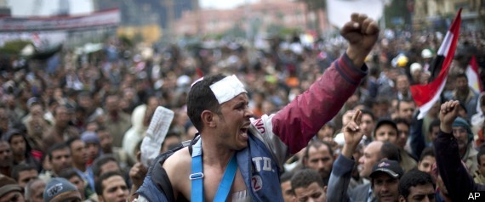

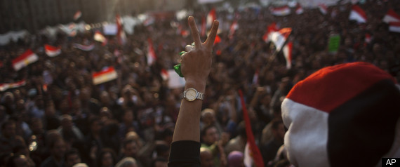

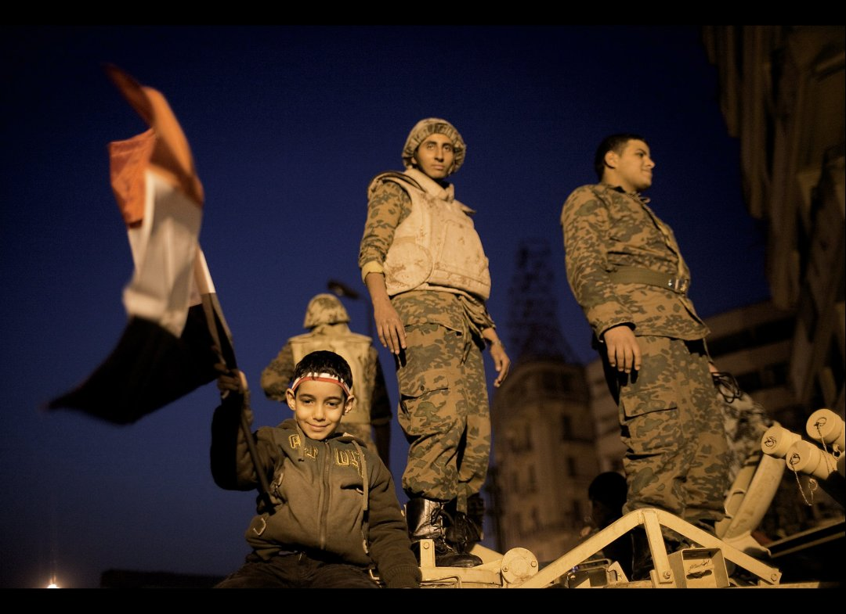

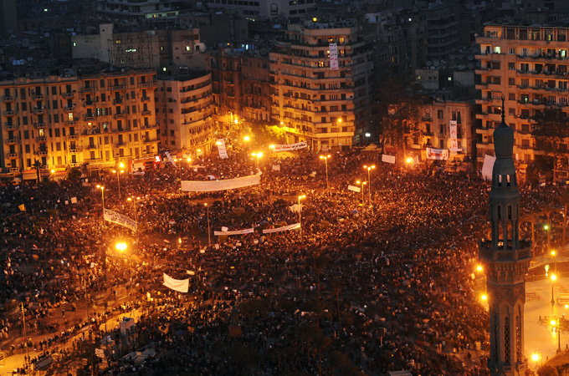

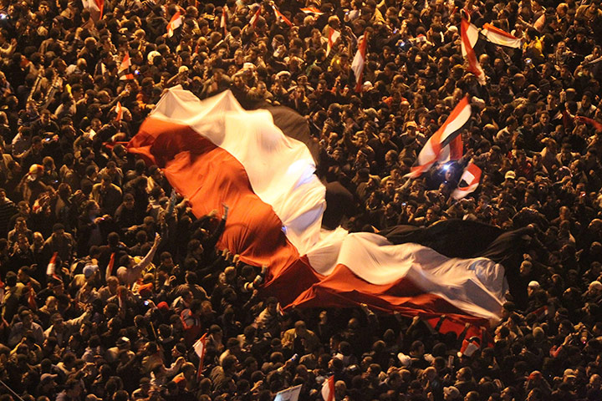

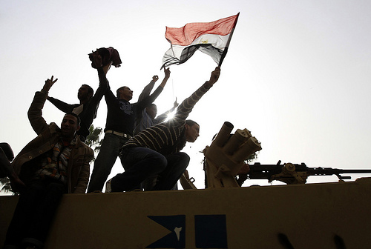

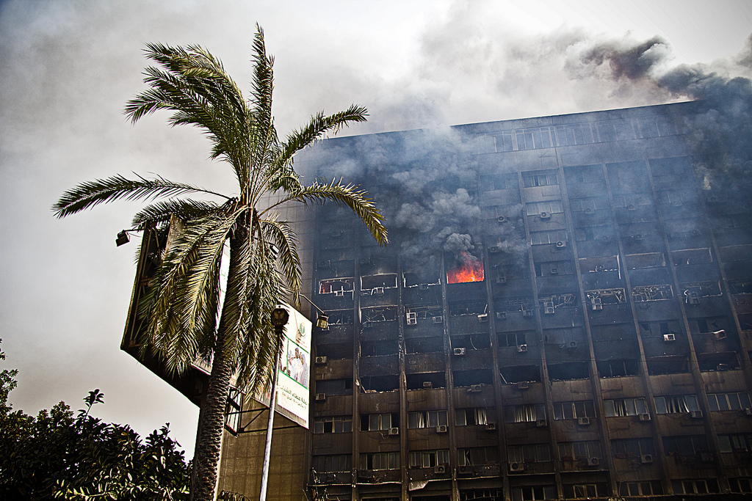

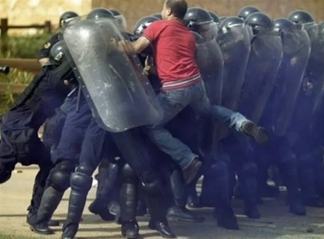

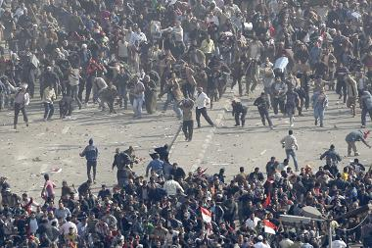

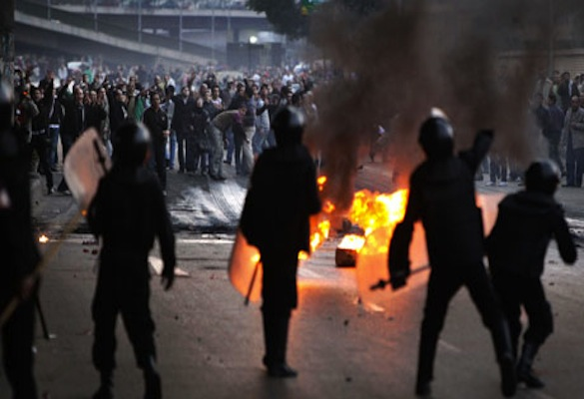

Summary Table:

Code | G3.9.10
Title of Activity | Human beings... Have human rights
Type of Activity | Brainstorming session
Location of Activity | Classroom
Duration | 45 minutes possibly 2 sessions 45 minutes each
Optimum student number | Groups of 15 students
Pre-requests
Purpose and short description | The students will be introduced to the concept of having rights, when these rights are valid and when they are not. They will understand that every human being has a set of rights but also a set of responsibilties that go along.
Learning Objectives | - Learn to define words according to personal experience  - Understand the meaning of human rights with what it entails of responsibiltities
Skills | Presentation, confining ideas, listening, arguing points of view, stating hypothesis
Necessary Materials | Flip charts, markers, human rights glossary
Additional information
Vocabulary | Human, right, existence, luxury, respect, dignity, equality, convenience, universal declaration of human rights
Assessment Method | The success in reaching a unified definition in line with the UDHR
Materials for Assessment | Pens and papers
Extension and/or Adaptation ideas | Grade 9  Social Studies  Term 1  Unit 2 lesson 2 “Population distribution in the world”  Unit 2 lesson 3 “Population characteristics”  Term 2
Information sources (if any)

Links to EG school curriculum: Recommendation
Class / Discipline | Grade 9, social studies
Semester/Unit | Unit 1 lesson 1 “Resources over the world”

Implementation procedures
PART A: What Does It Mean to Be Human? (20 minutes)
1. Write the words "HUMAN" and "RIGHTS" at the top of chart paper or a blackboard. Below the word "human" draw a circle or the outline of a human being.
Ask the students to brainstorm in their groups what qualities define a human being and write the words or symbols inside the outline. For example, "intelligence," "sympathy.", etc…
2. Next ask the students what they think is needed in order to protect, enhance, and fully develop these qualities of a human being. List their answers outside the circle, and ask participants to explain them. For example, "education," "friendship," "loving family." (Note: Save this list for use in Part B)
3. Discuss:
- What does it mean to be fully human? How is that different from just "being alive" or "surviving"?
- Based on this list, what do people need to live in dignity?
- Are all human beings essentially equal? Why?
- Can any of our "essential" human qualities be taken from us? For example, only human beings can communicate with complex language; are you human if you lose the power of speech?
- What happens when a person or government attempts to deprive someone of something that is necessary to human dignity?
- What would happen if you had to give up one of these human necessities?
4. Explain that everything inside the circle relates to human dignity, the wholeness of being human. Everything written around the outline represents what is necessary to human dignity. Human rights are based on these necessities.
PART B: What Is a Right? (20 minutes)
1. Brainstorm for the many meanings "right" can have (e.g., "correct," "opposite of left," "just.") Consider common expressions like "We’re within our rights" or "You have no right to say that." Record these different meanings on the board. What is the meaning of "right" when we speak of a human right?
2. In small groups, brainstorm a definition for human rights and write these possibilities on the board. Try to evolve a definition that everyone can agree upon and write it on a chart sheet by itself.
3. Write on the board this definition of human rights:
Human rights belong to all people regardless of their sex, race, color, language, national origin, age, class, religion, or political beliefs. They are universal, inalienable, indivisible, and interdependent.

Read these sentences from the Universal Declaration of Human Rights (UDHR) and explain that this document sets the standard for how human beings should behave towards one another so that everyone’s human dignity is respected:
…recognition of the inherent dignity and of the equal and inalienable rights of all members of the human family is the foundation of the freedom, justice, and peace in the world…
Preamble
Universal Declaration of Human Rights
All human beings are born free and equal in dignity and rights. They are endowed with reason and conscience and should act towards one another in a spirit of brotherhood.
Article 1
Universal Declaration of Human Rights

- What is meant by universality? By inalienable? By indivisible? By interdependent? Ask participants to look up these terms in a dictionary or in A Human Rights Glossary, Part V, "Appendices," and explain their meaning to the group.
4. Look back at the list of qualities that define a human generated in Part A.
5. Write "SURVIVAL/SUBSISTENCE," "HUMAN DIGNITY," and "CONVENIENCES AND LUXURIES" on another chart or blackboard. Discuss the meaning of these terms.
Consider the chart made in Part A. Place each item listed as necessary to fully develop human qualities under one of these headings. For example, is education necessary to survival? To human dignity? Is education a convenience or a luxury?
6. Discuss:
- Should human rights address only what a human being needs to survive? Why or why not?
- Should human rights also protect those things you classified under "conveniences and luxuries"? Why or why not?
- Some people in the world have only what is necessary to survive while others have luxury and convenience. Is this situation just? Is it a human rights violation?
- Can something be done to equalize the enjoyment of human dignity? Should something be done? If so, how? And by whom?

Summary Table:

Code | G3.9.11
Title of Activity | Inequality...
Type of Activity | Group discussion
Location of Activity | Classroom
Duration | 2 sessions, 45 minutes each
Optimum student number | Groups of 10/ 15 students per group
Pre-requests
Purpose and short description | The students will analyze the different reasons and factors that create inequality in society, they will try to identify the reasons of these factors and when they are considered inequality.
Learning Objectives | - Understanding the meaning of inequality  - Analsyzing reasons causing inequality in societies  - Finding possible solutions to decrease and/ or illeminate inequality factors when possible
Skills | Analyzing data, creating hypothesis, reading, writing
Necessary Materials | Papers, pens
Additional information
Vocabulary | Inequality, equaty, gender, race, discrimination,inheritance, wealth, privelege, opporunity, mind map, access
Assessment Method | The results and solutions found after discussion
Materials for Assessment | Papers and pens
Extension and adaptation | Social studies  Unit 2 lesson 2 “Population distribution in the world”  Unit 2 lesson 3 “Population characteristics”  Term 2  Math  Unit 6 “Data collection”
Information sources (if any)

Links to EG school curriculum: Recommendation
Class / Discipline | Grade 9, Social studies
Semester/Unit | Unit 1 lesson 1 “Resources over the world”

Implementation procedures

Mind map:
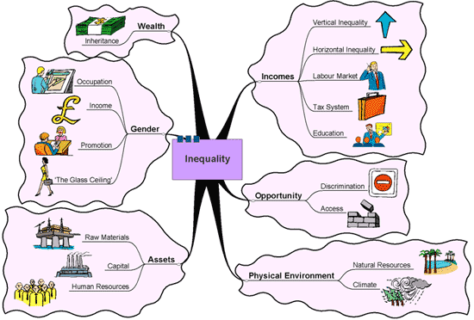
- Incomes
  - Vertical Inequality
  - Horizontal Inequality
  - Labour Market
  - Tax System
  - Education
- Opportunity
  - Discrimination “Race, religion, etc…”
  - Access
- Physical Environment
  - Natural Resources
  - Climate
- Assets
  - Raw Materials
  - Capital
  - Human Resources
- Gender
  - Occupation
  - Income
  - Promotion
  - 'The Glass Ceiling'
- Wealth
  - Inheritance
- Introduce the class to the concept of inequality using the above mind map
- Split the students in 5 subgroups of 10/ 15
- Ask each group to come up with as many factors as possible that might create inequality “gender, age, income, health, Race/ religion, etc…” “10 minutes”
- Ask each group to identify in order of importance the inequality factors they find “5 minutes”
- Each group should take one factor and discuss the following: one group can take gender, another income, etc…” “30 minutes”
  - Reasons of this factor
  - When is it considered unaccepted inequality
  - What can be done about it
  - Role of society in increasing/ decreasing this factor
  - From personal experience if any, to try and put some examples
- Ask the students to discuss within the groups to create links between factors “20 minutes”
- Ask each group to present their case based on their given factor “5 minutes” 25 minutes”

Code | G3.9.12
Title of activity | The gender playing field
Type of activity | Group activity
Duration | 1 hr
Location | Classroom
Optimum student number | Entire class group and groups of 6
Pre-requests
Purpose and short description | Students will discuss issues relating to gender equality and will discuss whether or not and in what ways men and women have become more or less equal in recent years.
Learning objectives | - Students will assess whether they feel that men and women are becoming more equal or whether there are still many obstacles to overcome.
Skills
Necessary materials
Additional information
Vocabulary | generations, profoundly, unbalanced, triumph, evolving, interact, distinct, perception, observant, pragmatism, tempered, idealism
Assessment method | Students will be evaluated based on written journal responses and thoughtful answers to questions about changing attitudes about women and men.
Materials for assessment | n/a
Extension and/or adaptation ideas
Information sources (if any)

Links to EG school curriculum: Recommendation
Class / Discipline | Grade 9, Social studies
Semester/Unit | Unit 1 lesson 1 “Resources over the world”

Implementation procedures (Methodology)

- The teacher informs students that they are going to explore the issue of equality and inequality in terms of men and women i.e. gender equality/inequality.
- Students are placed into groups of 6 and are asked to answer the following questions:

  - Do you think that men and women are becoming more equal? If yes, in what way? If no, why not?
  - In what ways can it be difficult to achieve equality between men and women is difficult to achieve?
3. Each group is called on to share their answers with the class. Please note: there is no right or wrong answer here but depends on the students own views and perspectives.
4. The teacher distributes worksheet one below or gets students to write the questions in their copies. Each student must individually answer these questions.
5. Students are then placed back into their groups of 6 and each group must again discuss the questions with each member of the group giving their own views on the question.
6. The teacher calls on each group to share their answers with the class.
7. Students are then placed back into their groups of 6. Groups must discuss the following questions based on gender equality:

- What is meant by the phrase "gender equality"?
- Is gender equality important? Why or why not?
- Do you feel that men and women are becoming more equal in the workplace, and why?
- Do you feel that men and women are becoming more equal in the home, and why?
- Do you think that men and women can accomplish the same goals, and why?
- What past and present attitudes have prevented women from being on a "level playing field" with men?
- What past and present efforts have helped women gain rights and privileges that at one time were solely afforded to men?
- Do you think that men and women will continue to become more equal in the future, and why?
- Do you think that men and women should be equal, and why?

8. The teacher calls for contributions from the discussion from each group and concludes the lesson by assigning one of the two possible modifications and extension activities below.

Assessment
Students will be evaluated based on written journal responses and thoughtful answers to questions about changing attitudes about women and men.

Possible modifications and extensions:
1. In response to the "Acting Like a Man" discussion as outlined above further discuss what the phrases "act like a man" and "act like a woman" mean to you. Then, interview a woman in a predominantly male field or a man in a predominantly female field about how one achieves success in a field traditionally identified with the opposite gender.

2. In response to "The Generation Gap" question, ask your parents and grandparents to respond to the questions provided in the worksheet. How do their answers differ, and why? In what ways have attitudes about gender changed from your grandparents' youth to today? In what ways have they remained the same?

Tools/Resources

Worksheet one:

There are no "right" or "wrong" answers to any of these questions; the only correct answer is the honest answer.
A Woman in Charge?
Do you think that there will be a woman president in your lifetime? Why or why not?
Acting Like a Man
What does the phrase ‘acting like a man’ and ‘acting like a women’ mean to you?
Do women have to act like men in the workplace to be successful? Why or why not?
Do teachers treat boys and girls differently, and why do you feel this way?
Are girls encouraged to play sports? Are girls expected to be as successful in sports as boys? Why or why not?
If Men Could Have Babies
Question Posed to Boys: If new technology was developed to allow men to have babies, would you want to? Why or why not?
Question Posed to Girls: If new technology was developed to allow men to have babies, would you want your husband to? Why or why not?
The Work-Child Conundrum
Is there a double-standard in your home between what males and females are capable of doing? Explain.
What are the different roles of your parents in your home?
How do you plan on creating a balance between working and raising your children?
The Generation Gap
What do you think are the biggest differences between your life and the lives of your parents?
What sense do you have about whether or not there was a struggle for equality between men and women in the past, and how do these past struggles benefit us today?

Adapted from: http://www.abc.net.au/civics/democracy/pdf/td_primary.pdf
Adapted from http://www.huffingtonpost.com/2011/01/30/egypt-revolution-2011_n_816026.html

