Effective mentoring and coaching involves:
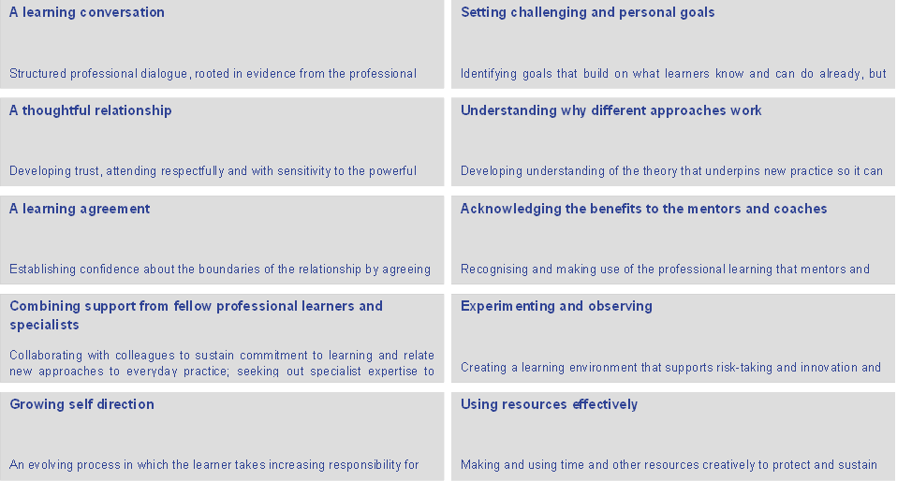
Statements from CUREE : National Framework for Mentoring and Coaching

