Ideas for the temification of your science lessons
The amazing polydensity bottle
Engagement: the mystery
You may have seen this demonstration on the web or at a conference. (https://www.youtube.com/watch?v=_75qjvMRVcc ) A bottle has two layers of clear liquid. Two different coloured plastic beads sit at the interface. When it is shaken the two layers disappear, the coloured beads migrate to opposite ends of the bottle and then come together as the interface forms. You can repeat this as often as you like. How does it work?
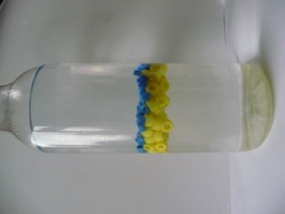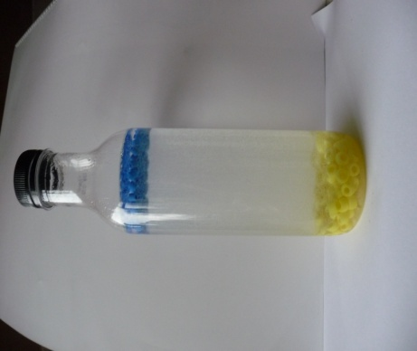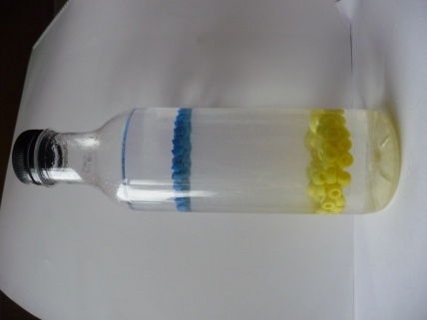
Before shaking After shaking Part-way back
Explore
We have two clear liquids which don’t mix but on shaking they mix for a time and then separate again. This is our first mystery. The formation of the two layers is in itself a mystery. Start with an empty 1 L clear plastic bottle. Pour 400 cm3 of propan-2-ol (isopropanol, rubbing alcohol) and 400 cm3 distilled/deionized water and shake with the cap on. The two liquids mix and dissolve in each other to give a single layer. Propan-2-ol is strongly polar due to –OH group and is completely miscible in water like methanol and ethanol. Now add 100 g of salt (sodium chloride) to the bottle and shake until dissolved. (Solubility of NaCl in water at 25ºC is 360 g per L) As the salt dissolves the liquid separates into two layers with the salt solution at the bottom as it is denser. When you shake this mixture, the two layers mix for a time and then separate out. Why does salt make the alcohol layer separate out?
To make the density bottle you need two sorts of plastic beads, of two different colours. Is there anything different between the beads besides colour? How could you measure their density? Add 100 of each the two sorts of beads to the bottle and close it. The beads will sort themselves out and sit near the interface one colour at the bottom of the top layer and the other at the top of the bottom layer. When the bottle is shaken, the layers mix, the beads separate and move to the top and the bottom, and then slowly move back to the centre as the interface reforms.
(Two sorts of beads are needed: one sort is known as pony beads, used for making necklaces, and they come in various colours. They are made from acrylic plastic and I got them from beadbubble.com at €1.56 a packet of 100 plus postage. The second sort of bead is the Hama (also known as Perler) beads, bought in sets from toy shops, and used to make designs. When heated these beads fuse together. A set with 6,000 beads costs €14.49 from Smyths. They are made of polyethene so they can be fused by a hot iron.)
The mystery is about density and to solve it you need to know the densities of the liquids and the beads. Your students should already have learnt how to measure the density of liquids and solids, so get them to measure the density of the two layers in the bottle and of the two sorts of beads and tabulate their results.
Explain
Get your students to think about why salt in the water causes the alcohol layer to seperate out. Is it about density differences? Get them to think about polarity and solubility. The ionic salt dissolves in water and the two sorts of ions are bonded to water molecules. There is a competition for water molecules between the ions and the polar propan-2-ol molecules. The result is that the alcohol molecules are rejected from the salt solution and form a separate layer. The alcohol has a lower solubility in a solution of high ionic concentration (ionic strength). The alcohol layer will contain some water in solution. (This sort of behaviour is used in making soap, where the soap is salted out of solution by adding salt.)
We now have two layers of different density. The less dense alcohol layer floats on the denser water layer. The two beads also have different density. The pony beads are denser than the fusible beads. When the bottle is shaken, the two layers mix to form an emulsion (small droplets of one in the other), rather than true solution, and on standing it separates out into two layers again. The density of the emulsion is between that of the two layers: it is denser than the fusible beads (so they float to the top) and less dense than the pony beads (so they sink to the bottom.)
Elaborate
How could this be developed further? One could investigate the relation between the salt concentration and the separation into layers. How could you use the different densities of salt solutions to determine the density of a plastic bead? They could link it the salting out effect used in soap manufacture. Salting out is also used to separate out proteins from an aqueous solution.
Evaluate
Monitor the students’ ability to observe and record accurately what is happening. Evaluate their ability to design and carry out experiments to measure density using previous knowledge. Assess how well they can use the measured densities of the liquids and the beads to explain what is happening in the bottle.
HOW THE MYSTERY BEAD BOTTLE WORKS
http://scifun.chem.wisc.edu/HomeExpts/bead-bottle.htm
The mystery bead bottle contains two liquids, a concentrated solution of salt (sodium chloride) in water and isopropyl alcohol. The two liquids do not mix. Although isopropyl alcohol will mix completely with pure water, the salt dissolved in the water prevents the alcohol from mixing.
The salt solution is denser than the isopropyl alcohol. The density of the salt solution is 1.13 grams per cubic centimeter, 1.13 g/cm3. The density of the alcohol in the bottle is about 0.88 g/cm3. (This is greater than the density of pure isopropyl alcohol, because there is some water dissolved in the alcohol.) Therefore, the salt solution sinks to the bottom, and the isopropyl alcohol floats on top.
There are two different kind of beads in the bottle. The larger pony beads have a density of 1.02 g/cm3. The smaller Perler beads have a density of 0.90 g/cm3. Both kinds of bead are less dense than the salt solution, so they float on the salt solution. They are both denser than the isopropyl alcohol, so they sink to the bottom of the alcohol. They rest were the two liquids meet, in the middle of the bottle.
When the bottle is shaken, the salt water and isopropyl alcohol are mixed together and form a temporary emulsion (tiny drops of each liquid mixed together). The density of the emulsion is the average of the densities of the two liquids, namely (1.13 + 0.88)/2 or 1.00 g/cm3. The density of the emulsion is less than the density of the pony beads, so the pony beads sink to the bottom in the emulsion. The density of the emulsion is greater than the density of the Perler beads, so the Perler beads float to the top of the emulsion. As the bottle rests, the emulsion separates into its two components. The salt water separates at the bottom and the alcohol at the top. The pony beads float to the top of the salt water, but stay below the emulsion. The Perler beads sink to the bottom of the alcohol, but remain above the emulsion. As the emulsion separates, the beads come together again at the middle of the bottle.

