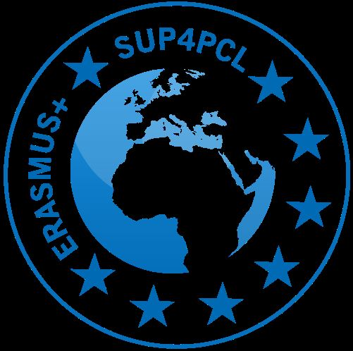

School and University Partnership for
Peer Communities of Learners
Project number:
573660-EPP-1-2016-1-EG-EPPKA2-CBHE-JP (2016-2516/001-001)

Project Monitoring and Evaluation
UoL site visit report (PME10)

University Visited

Dates of Visit

Members of UoL team attending

Members of host FoE team attending

Other attendees (EU partners, AUC)

Focus of visit (related to project sub-objectives)

Sources of evidence

Progress on Sub-objective #6 | Develop school mentors in PD schools
Indicators of achievement | 25 mentors trained  (5 in each Lead School)
Achievement criteria | - Mentor skills are enhanced and developed  - Reports and surveys evidence coaching and mentoring techniques in practice in schools  - School mentors train new mentors in schools  - Teaching materials are effectively and sustainably disseminated to teachers in schools  - Establishment of sustainable clusters of PD schools
Brief outline of evidence collected (for example):
- Questionnaire (PCS2)/interview data
- PCL surveys (PCS3)
- Reflective journals (PCS4)
- Weekly school visit reports (PCS5)
- School policy documents and development plans
- Meetings with FoE mentors and project leads
- Meetings with school colleagues?
Overview of progress on sub-objective: (narrative summary of outcomes of site visit)
*specifically, reporting on progress since Baseline Assessment

Agreed current Level of Achievement*
0 = no progress
5 = objective fully met
*to be discussed and agreed by Case Study FoE teams and UoL

