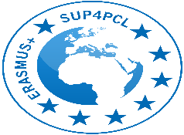

School and University Partnership for Peer Communities of learners (SUP4PCL)

Project number: 573660-EPP-1-2016-1-EG-EPPKA2-CBHE-JP (2016-2516/001-001)

Webinars

Organized by: The American University in Cairo (AUC), Egypt
Location: Online

Time | Topic
February, 2021 | School and University Partnerships and Professional Development Schools
 | Mentorship
 | STEAM
 | Integrated learning and teaching
March, 2021 | Peer Communities of Learners
April, 2021 | Action research by teachers
 | Teachers as Leaders

