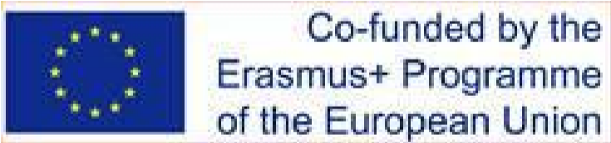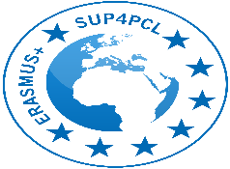

Disclaimer: "This project has been funded with support from the European Commission. This presentation reflects the views only of the author, and the Commission cannot be held responsible for any use which may be made of the information contained therein

School University Partnership for Peer Communities of Learners SUP4PCL
Project number: 573660-EPP-1-2016-EG-EPPKA2-CBHE-JP
This project was awarded to The American University in Cairo and began in 2017 with the support of The European Community Action Scheme for the Mobility of University Students (Erasmus+) with our partners: Ain Shams University, Helwan University, Alexandria University, University of Limerick, Martin Luther University, University of Leicester and University of Northampton. The project began with a signed memorandum of understanding between The Ministry of Higher Education and Scientific Research and The Ministry of Education and Technical Education. The project aims at creating a strong partnership between the 3 Egyptian faculties of education and 45 public professional development schools to support a dual reform process at both school and university levels. The project has succeeded in establishing a number of innovative strategies to set the reform in motion and to create a profound educational and cultural transformation in each of the participating institutions
Innovative strategies:
- Creation more than 75 peer communities of learners at schools and universities
- Establishing a mentorship and coaching relationship between 59 university faculty and 162 school teachers
- Designing and producing a joint learning and teaching materials around STEM, SD and GC
- Coaching teachers and faculty on introducing technology in teaching and learning
- Universities coaching schools on special needs education, activity based learning,
Cultural transformation and behavior patterns both in MOE schools and FOEs and based on the validated instruments used are:
- Reflection now a habit of mind
- Collaborative learning is in place.
- Collaborative teaching emerging.
- Activity-based learning now pronounced.
- Student teachers emerging at the school level.
- Innovations promoted in teaching pedagogies.
- Power relations altered with much more empowerment to teachers and young faculty members.
- Power relations altered with students now evaluating their teachers.
- Intrinsic motivation nurtured through FOE mentorship
- Appreciation of cultural exchanges between EU partners and Egyptian FOEs and schools.
- Cultural transformation from individualism to collaboration and a sense of community.
Skills acquired:
- Barriers to the use of technology gradually disappearing.
- The use of English language strengthened (oral & written).
- Research skills greatly developed for faculty, teachers and students, which led to new innovative research courses at the universities
Outcomes of learning and exchange:
- Student achievement improved in some schools as a result of PCLs.
- School attendance markedly improved as a result of PD & PCLs.
- Views of faculty, families and students much more appreciative of the teaching profession.
- Teachers now seeking CPD through university (MA & diplomas)
- Civic engagement of students greatly enhanced in some schools (special needs & minorities)
- Four memorandum of understanding were signed between partner universities which led to joint supervision post graduate studies and exchange programs
- Three technology labs for the PCLs with the schools were established at each of the Egyptian universities

